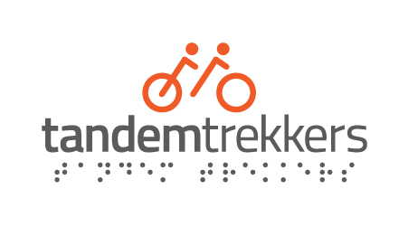

**TANDEM TREKKERS MEMBERSHIP APPLICATION FORM**

Please fill out the details below and hand back or scan and email to [membership.secretary@tandemtrekkers.org.uk](mailto:membership.secretary@tandemtrekkers.org.uk) Membership is free of charge.

**Personal Details:**

|  |  |
| --- | --- |
| Name: |  |
| Address: |  |
| Postcode: |  |
| Mobile Number: |  |
| Email Address: |  |
| Date of Birth: |  |

## Disability:

The Equality Act 2010 defines a disabled person as anyone with a physical or mental impairment that has a 'substantial' and 'long-term' negative effect on their ability to do normal daily activities.

|  |  |  |
| --- | --- | --- |
| Do you consider yourself to have a disability? | Yes | No |

|  |  |
| --- | --- |
| If Yes, what is the nature of your disability? Please tell us about any special needs or care that is relevant. Please continue overleaf if necessary. |  |

|  |  |  |
| --- | --- | --- |
| Do you have any allergies or medical condition which might become an issue when attending a Tandem Trekker ride or event? | Yes | No |

|  |  |
| --- | --- |
| If yes, please tell us about the allergy or condition and what action needs to be taken if the allergy or condition happens? |  |

**Emergency Contact Details:**

Please insert the information below to indicate the person(s) who should be contacted in the event of an incident/accident.

|  |  |  |
| --- | --- | --- |
| Contact name(s): |  |  |
| Emergency Contact No(s): |  |  |

**Membership, Guidance & Instruction, Communication and Promotional Material:**

I would like to apply for membership of Tandem Trekkers as a – (please place an X in one of the boxes below)

Volunteer pilot **[ ]**  
  
Stoker **[ ]**  
  
Solo rider **[ ]**  
  
A non-riding supporter **[ ]**

In order to provide anonymous statistics and to help show the diverse nature of the membership of Tandem Trekkers, we would like to collect the gender and ethnicity data of our members. We have to provide this data to organisations who have or may award grants / funding etc. The categories are those required by the organisations we have to deal with. We would be grateful if you would provide the optional data below.

Gender Male **[ ]** Female **[ ]**Other  **[ ]** Prefer not to Say **[ ]**

Ethnicity White **[ ]** Asian / Asian British **[ ]**Black / Black British **[ ]** Mixed **[ ]**

Other **[ ]** Prefer not to Say **[ ]**

I agree to abide by the rules and regulations of the charity and in accordance with the constitution and code of conduct

I confirm that Tandem Trekkers have provided appropriate and sufficient guidance and instruction pertaining to tandem cycling and I agree to observe and comply with the reasonable directions of the ride/session leaders.

I give my consent to Tandem Trekkers holding and processing my details as provided above and would like to receive communications from Tandem Trekkers:

By email: **[ ]** By messaging service such as WhatsApp: **[ ]**

By phone: **[ ]**  By post: **[ ]**

I hereby give Tandem Trekkers permission to use photographic material containing images of myself (with or without my name) in future promotions and on social media where my name will not be mentioned*. [Delete if you would prefer not to appear in any future publicity].*

**SIGNED:** **DATE:**

**TT USE ONLY:**

|  |  |  |  |  |
| --- | --- | --- | --- | --- |
| **Date Received** | **Opt-01** | **Opt-02** | **Opt-03** | **CHK List** |

Issued 03 25 Tandem Trekkers is a Registered Charity (1175326) htttp://tandemtrekkers.org.uk