**Tandem Trekkers Route Assessment**

**Ride route: Dalby Forest (Adderstone Long Route and return to Dalby Forest Visitor Centre)**

Route Assessed: Paul Stark, Keith Sandiford and Stevie Butler on 700c x 28-32 solo bikes on 7th May 2024. Weather: Warm and Overcast/Sunny.

This ride comprises two components. The first is the waymarked Adderstone Trail (Long Route – 12 miles) which is largely on forest roads made up of well compacted gravel. The first few hundred yards are slightly more technical and the path narrower than the remainder of the trail. There is also a short section on the Dalby Forest Road. The second element (5 miles) is the return to the Visitor Centre on the paved Forest Road.

It may be feasible to re-ride parts of the trail, providing time permits and a clockwise orientation is maintained,

Risks pertaining to the forest trail are as detailed below. However, given the nature of the surface and the assumed propensity for sections to rapidly become muddy, it is recommended the ride be postponed should any rain be forecast for the duration of the ride, or if the preceding day has been particularly wet.

It is proposed that all tandems will be towed to the start point at Adderstone Field to avoid the incline from the lower parts of the forest. Portacabin toilets are in situ. After completing the longer loop, most riders will follow the road back to the Visitor Centre whilst towing drivers will return by car and trailer. This may well mean that not all tandem pairs will be able to complete the second part of the ride. Solo riders/drivers and the ability to shuttle other drivers from the Visitor Centre back up to the start point will minimise any disruption and facilitate the road return to the Visitor Centre to be enjoyed by most Trekkers. Final arrangements can be crystallised on the day.

There is a £10.00 Entry Fee to Dalby Forest.

|  |  |  |  |  |
| --- | --- | --- | --- | --- |
|  |  |  |  |  |
| **Nr** | **Approx distance from start (miles)** | **Risk Description** | **Mitigation** | **Risk rating**  **Low / Med / High** |
|  | 0.0-12.0 miles | Except as detailed below, the route is on well compacted and reasonably wide forest tracks. There are numerous potholes, but these are generally quite small. There are also parts of the trail which consists of loose gravel and extra care must be taken, particularly when turning. The route should be ridden at a leisurely pace as set by the ride leader. | Extra care and vigilance. Keep to single file when encountering sections which are particularly pockmarked. | Low |
|  | 0.0-12.0 miles | The route is ridden in a clockwise orientation and is well waymarked with green arrows. However, some of these can be difficult to spot. There is a risk that tandems may get separated. Moreover, phone reception in the forest is unreliable. | Ride Leader and Back Marker to carry Walkie Talkies and ensure frequent re-groups – especially at Trail junctions/crossroads | Low |
|  | 0.0-12.0 miles | The trail is envisaged to be very popular at weekends and whilst the route is essentially traffic free (though the occasional vehicle may be encountered) walkers and other cyclists (including children) are likely to be present. | Give clear verbal instructions, and make good use of bells when encountering walkers or slower cyclists. Be prepared to give way to oncoming vehicles. Dismount if necessary. | Low |
| START | 0.0 | Start point – Adderstone Field Car Park |  |  |
| 1 | 0.0-0.5 miles | The first half mile of this route follows a narrow, twisty path. | Ride slowly and exercise care and vigilance. | Low |
| 2 | 5.0 miles | Short section on Dalby Forest Road. Possibility of vehicles. | Extra care. | Low |
| 3 | 12.0 -17.0 miles | Return to Visitor Centre on Dalby Forest Road. Part of this route is very steep and speeds of 40 mph are easily attainable. | Do not speed. Use Drag Brake. Watch out for traffic. Do not overtake other tandems. Keep to the left. | Low/Medium |
| END | 17.0 miles | Expect the Visitor Centre to be very busy | Dismount and walk with bikes to appointed seating area | Low |

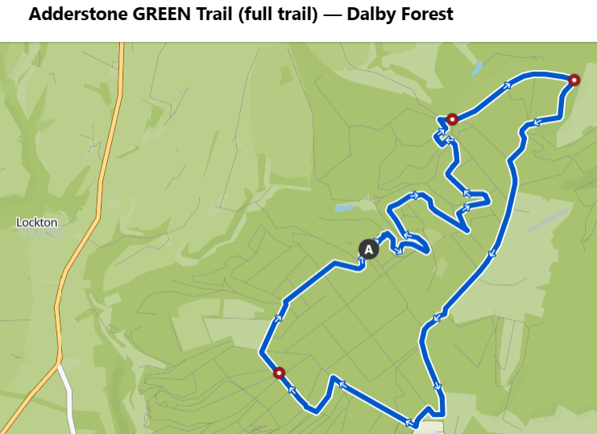

[Adderstone GREEN Trail (full trail) — Dalby Forest | bike Tour | Komoot](https://www.komoot.com/smarttour/e1369776844/zoom)

**General risk assessment notes applicable to all rides**

All riders should be encouraged to take part in activities that are within their capabilities.

All riders must wear a helmet.

High vis clothing to be considered for road riding.

The session leader should have checked the leader pack as per insert and have leader pack with them at all times. This must include first aid.

Sun protection and water advisable to be carried.

For exposed routes or winter rides suitable clothing is essential along with spare water or windproof items.

All ride leaders should familiarise themselves with the contents of the ride leader pack specifically tools, spares, first aid and survival equip.

Ride leader should carry suitable navigation aids and check route assessment before commencing ride.