**Tandem Trekkers Route Assessment**

**Ride route: Humber Bridge to Elsham and back via Deepdale Garden Centre**

**OS Grid ref:- TA 020 259 loop back to start**

Approx route/circuit length: 22 miles of varying terrain including cycle path on Humber Bridge, village centre roads and rural B roads.

**Terrain**

The route is novel as it includes using the Humber Bridge cycle path to cross the Humber before navigating the busy village centre before riding on exposed undulating minor B roads in the Lincolnshire countryside before returning back through the village centre and over the bridge.

**Other potential users of circuit or route (such as pedestrians, horses, cars etc):**

This bridge is a popular walking spot, village / town centre roads can be busy with vehicular traffic and the rural roads are often poorly surfaced so car needs to be taken around potholes.

**RIDE LEADER TO SCOPE EXTENT OF ACTUAL RIDE TO BE UNDERTAKEN.**

Date / details of route assessment :

31st March 2024 - Barney Harle & party of 3 from Beech Holme tandem group using road bikes, e-bike and e-tandem full route navigated at pace in well under 2 hours.

**Car parking / trailer parking notes:**

Large free car park at start of ride with public toilets.

Very busy public are so consider using a trailer lock.

**It is proposed to use Deepdale Garden Centre as a café stop however TileWorks at the SW bridge portal is also a possibility if somewhat more expensive.**

**Schedule of route / waymarks / particular hazards (points should appear on annotated map)**

|  |  |  |  |  |  |
| --- | --- | --- | --- | --- | --- |
|  |  |  |  |  |  |
| Nr | Grid ref | Distance from start  (miles) | Risk Description | Mitigation | Risk rating  Low / Med / High |
| START | TA 020 259 | 0 | Start point Humber Bridge viewpoint car park |  |  |
| 1 | TA 028 225 | 2.8 | Town centre -this involves navigation of the town / village centre roads. | Warning and regroup before navigating town centre – will need a lead rider who is aware of route and try to keep group close – total distance about 600m | Med |
| 2 | TA 030 212 | 3.6 | Soon after leaving town centre on an uphill stretch turn right onto Horkstow Rd as housing stops. | Post a rider to mark junction as it is not signed and could be missed if group has broken up | Low |
| 3 | SE 990 192 | 8.0 | As Horkstow Rd starts to descend take an immediate left on a very minor junction | Suggest regrouping at farm on right hand side before sending rider ahead to mar junction | Low |
| 4 | TA 033 135 | 12.8 | Second left at 5 way crossroads with B1206 to follow route | Consider marking junction for both traffic control and ensure route and grouping | Low |
| 5 | TA 062 151 |  | Left turn at crossroads following NCN signposted route | Ride leader to ensure group together and follows route | Low |
| 6 | TA 050 187 | 17.2 | Straight on at crossroads with B 1206 – beware busier traffic crossing | Consider marking junction for both traffic control and ensure route and grouping | Med |
| CAFÉ | TA 047 191 | 17.6 | Deepdale Garden Centre Cafe |  | NIL |
| 7 | TA 028 225 | 19.2 | Town centre -this involves navigation of the town / village centre roads. | Warning and regroup before navigating town centre – will need a lead rider who is aware of route and try to keep group close – total distance about 600m | Med |
| END | TA 020 259 | 22.0 | Start point Humber Bridge viewpoint car park |  |  |
|  |  |  |  |  |  |

**GENERAL WARNINGS / NOTES SPECIFIC TO THIS RIDE**

The ride starts and ends with crossing the Humber Bridge on the dedicated cycle / walking deck, this is exposed to the wind and can be busy with other pedestrian / cycle traffic – brief pilots and consider a regroup as you leave the bridge to enter Barton.

Barton town centre can be busy so caution – regrouping and junction markers using experienced riders may be useful – especially if riding as a very large group.

Most of the route is on rural minor roads with come soft edges and potholes so pilots need to be vigilant.

**Barton Town Centre Map.**

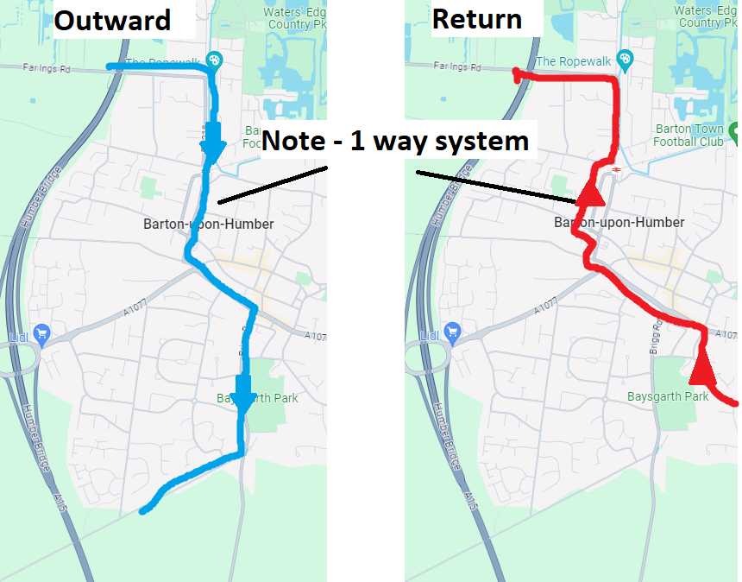

**General risk assessment notes applicable to all rides**

* All riders should be encouraged to take part in activities that are within their capabilities.
* All riders must wear a helmet.
* High vis clothing to be considered for road riding
* The session leader should have checked the leader pack as per insert and have leader pack with them at all times. This must include first aid.
* Sun protection and water advisable to be carried.
* For exposed routes or winter rides suitable clothing is essential along with spare water or windproof items
* All ride leaders should familiarise themselves with the contents of the ride leader pack specifically tools, spares, first aid and survival equip.
* Ride leader should carry suitable navigation aids and check route assessment before commencing ride.

**Annotated map**

