Tandem Trekkers Route Assessment

Ride route: Humber Bridge to Elsham and back via Deepdale Garden Centre
OS Grid ref:- TA 020 259 loop back to start

Approx route/circuit length: 22 miles of varying terrain including cycle path on Humber Bridge, village centre roads and rural B roads.

Terrain
The route is novel as it includes using the Humber Bridge cycle path to cross the Humber before navigating the busy village centre before riding on exposed undulating minor B roads in the Lincolnshire countryside before returning back through the village centre and over the bridge.

Other potential users of circuit or route (such as pedestrians, horses, cars etc):
This bridge is a popular walking spot, village / town centre roads can be busy with vehicular traffic and the rural roads are often poorly surfaced so car needs to be taken around potholes.

RIDE LEADER TO SCOPE EXTENT OF ACTUAL RIDE TO BE UNDERTAKEN.

Date / details of route assessment :
31st March 2024 - Barney Harle & party of 3 from Beech Holme tandem group using road bikes, e-bike and e-tandem full route navigated at pace in well under 2 hours.

Car parking / trailer parking notes:
Large free car park at start of ride with public toilets.
Very busy public are so consider using a trailer lock.

It is proposed to use Deepdale Garden Centre as a café stop however TileWorks at the SW bridge portal is also a possibility if somewhat more expensive.

Schedule of route / waymarks / particular hazards (points should appear on annotated map)

Nr | Grid ref | Distance from start  (miles) | Risk Description | Mitigation | Risk rating  Low / Med / High
START | TA 020 259 | 0 | Start point Humber Bridge viewpoint car park
1 | TA 028 225 | 2.8 | Town centre -this involves navigation of the town / village centre roads. | Warning and regroup before navigating town centre – will need a lead rider who is aware of route and try to keep group close – total distance about 600m | Med
2 | TA 030 212 | 3.6 | Soon after leaving town centre on an uphill stretch turn right onto Horkstow Rd as housing stops. | Post a rider to mark junction as it is not signed and could be missed if group has broken up | Low
3 | SE 990 192 | 8.0 | As Horkstow Rd starts to descend take an immediate left on a very minor junction | Suggest regrouping at farm on right hand side before sending rider ahead to mar junction | Low
4 | TA 033 135 | 12.8 | Second left at 5 way crossroads with B1206 to follow route | Consider marking junction for both traffic control and ensure route and grouping | Low
5 | TA 062 151 |  | Left turn at crossroads following NCN signposted route | Ride leader to ensure group together and follows route | Low
6 | TA 050 187 | 17.2 | Straight on at crossroads with B 1206 – beware busier traffic crossing | Consider marking junction for both traffic control and ensure route and grouping | Med
CAFÉ | TA 047 191 | 17.6 | Deepdale Garden Centre Cafe |  | NIL
7 | TA 028 225 | 19.2 | Town centre -this involves navigation of the town / village centre roads. | Warning and regroup before navigating town centre – will need a lead rider who is aware of route and try to keep group close – total distance about 600m | Med
END | TA 020 259 | 22.0 | Start point Humber Bridge viewpoint car park

GENERAL WARNINGS / NOTES SPECIFIC TO THIS RIDE

The ride starts and ends with crossing the Humber Bridge on the dedicated cycle / walking deck, this is exposed to the wind and can be busy with other pedestrian / cycle traffic – brief pilots and consider a regroup as you leave the bridge to enter Barton.

Barton town centre can be busy so caution – regrouping and junction markers using experienced riders may be useful – especially if riding as a very large group.

Most of the route is on rural minor roads with come soft edges and potholes so pilots need to be vigilant.

Barton Town Centre Map.
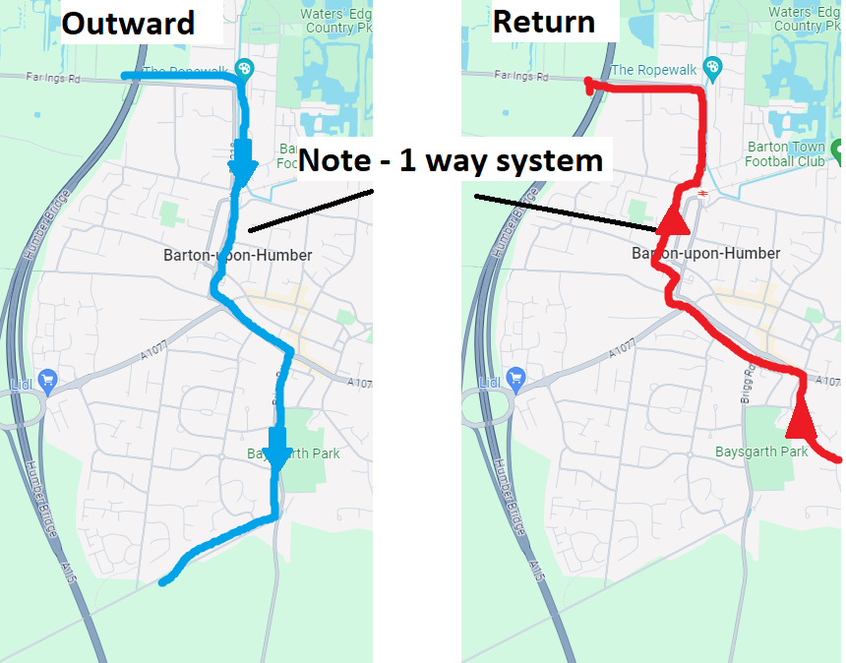
General risk assessment notes applicable to all rides
- All riders should be encouraged to take part in activities that are within their capabilities.
- All riders must wear a helmet.
- High vis clothing to be considered for road riding
- The session leader should have checked the leader pack as per insert and have leader pack with them at all times. This must include first aid.
- Sun protection and water advisable to be carried.
- For exposed routes or winter rides suitable clothing is essential along with spare water or windproof items
- All ride leaders should familiarise themselves with the contents of the ride leader pack specifically tools, spares, first aid and survival equip.
- Ride leader should carry suitable navigation aids and check route assessment before commencing ride.
Annotated map
