**Tandem Trekkers Route Assessment**

**Ride route: Boroughbridge – Ripon**

**Route Assessed:** Route assessed 1) 5 November 2022 and 2) 23 May 2023 by Stephen Butler.

**Weather during recces:** 1) drizzle, cloudy, breezy. 10’C 2) Dry, light wind. 20’C.

Route is mainly flat, approx. 16.5 miles including less than 500’ (150m) ascent mostly on country lanes, cycle paths and quiet rural roads. The only material hazard (Medium Risk) is short section around Ripon city centre. Clockwise loop follows NCN688 Way of the Roses on outward leg.

An extended spur continuing on Way of the Roses through Studley Royal Park to Fountains Abbey adds approx. 6.5 miles (23 miles in total) if wanted.

Being in a rural setting it is reasonable to encounter larger than normal agricultural vehicles which can be slow moving and to experience cross or headwinds on exposed stretches. Some lanes are also used by horse riders which should be passed slowly and widely when safe to do so and after giving a verbal alert to the rider. Ripon city centre approx. halfway has many opportunities to stop, eat or repair bikes.

**Cycle shops on route:** Bikemonger, Duck Hill, Ripon HG4 1BL 01765 604 400

Moonglu, 57 Blossomgate, Ripon HG$ 2AN 01765 601 106

**Toilet facilities:** Back Lane Car Park, Boroughbridge (start)

Ripon Bus Station, Victoria Grove, Ripon

Minster Road, Ripon (opposite Cathedral)

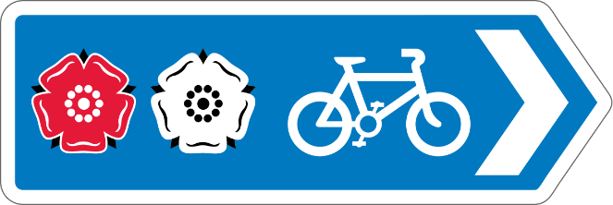The first half of the route, from Boroughbridge to Ripon is way marked by Way of the Roses (NCN688) signs like this

Almost the same route with an additional mile where I took a wrong turn on the recce!

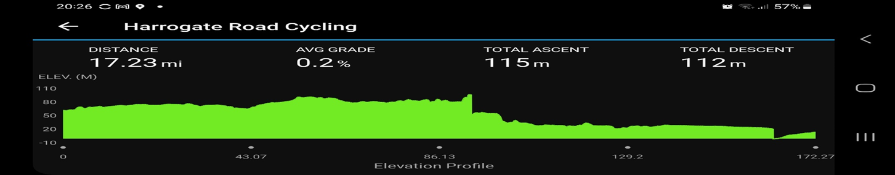

The route marked by blue solid line

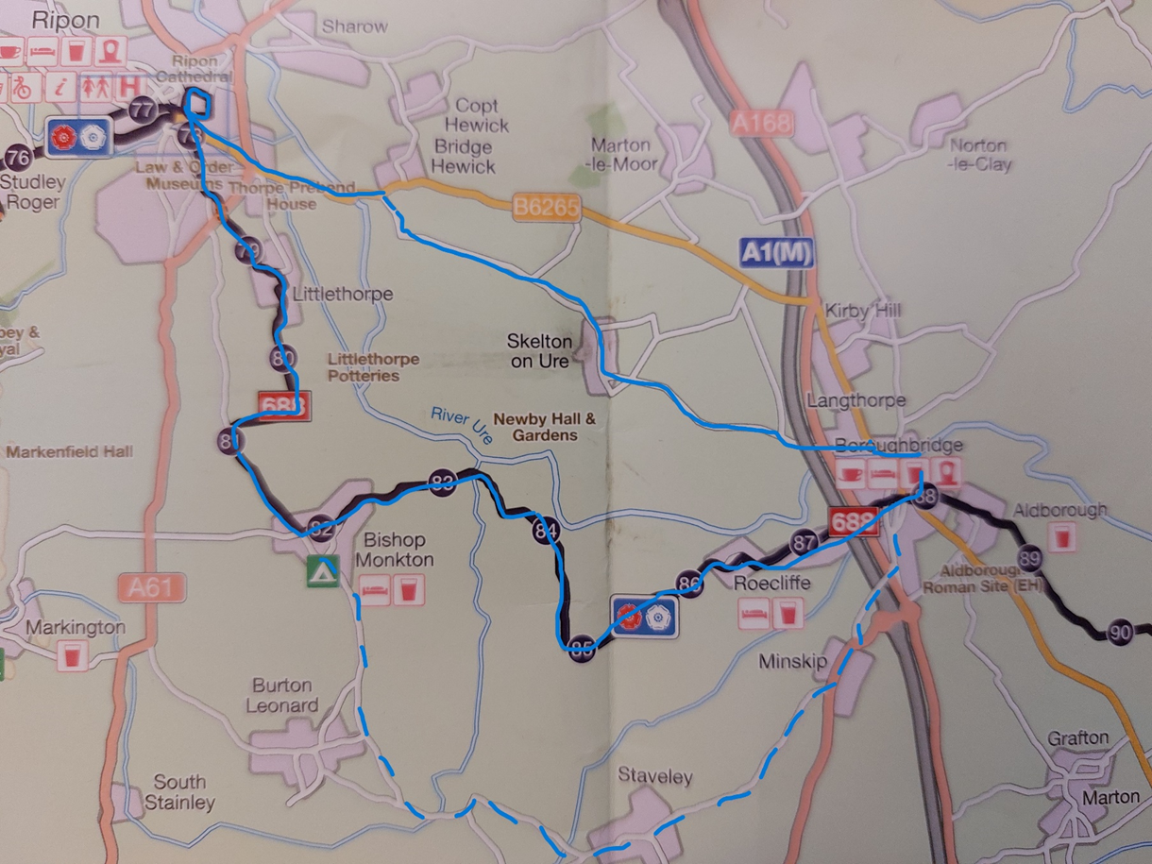

|  |  |  |  |  |
| --- | --- | --- | --- | --- |
| **Nr** | **Approx distance from start**  **(miles)** | **Route Description** | **Mitigation of risk(s)** | **Risk rating**  **Low / Med / High** |
| START | 0.0 | Start point – Back Lane Car Park, Boroughbridge |  |  |
| 1 | 100 metres | Route turns right into Fishergate, then left by Crown Hotel onto Horsefair B6265 | Mark junctions and if safe, convenient and appropriate, ride leader or appointee to stop traffic allowing tandems to join road without stopping. | Low |
| 2 | 0.3 miles | Take centre lane to follow Way of the Roses NCN688 Roecliffe Lane (watch out for Devil’s Arrows, one of these ancient stones is through a gateway on the left 10m beyond the large roundabout signpost) | Signal right before moving out, be prepared to stop and give way to oncoming traffic. If stopping at Devil’s Arrow move bikes off the road. | Low |
| 3 | 0.6 mile | At roundabout take second exit (effectively straight on) to stay on NCN688 Roecliffe Lane | Be prepared to stop and give way to oncoming traffic. Some large lorries access various industrial units and Paynes Dairy on left after motorway bridge. | Low |
| 4 | 6.0 miles | At X roads in Bishop Monkton village, signal right and stop at Give Way sign. Turn right onto Knaresborough Road, signposted Ripon & NCN688 | Consider marking junction but reasonably quiet road. | Low |
| 5 | 7.0 miles | Turn right onto minor road signposted Littlethorpe & NCN688 | Signal right before moving out, be prepared to give way and stop if necessary. Ensure all riders take right turn. | Low |
| 6 | 8.7 miles | At T junction take left turn to Ripon NCN688 (Littlethorpe Lane) | Be prepared to stop and give way if necessary | Low |
| 7 | 9.0 miles | Keep right at split in minor road and continue on Littlethorpe Lane | Be prepared to give way if necessary | Low |
| 8 | 9.4 miles | As A61 junction comes into sight take right hand turn onto cycle path, marked 688 Ripon | Take care turning right before junction.  Dismount at end of short cycle path and walk tandems across the main road via the crossing point. Ride leader to ensure all across main road safely. | Low -med |
| 9 | 9.6 miles | Turn right at T junction. Follow NCN688, turn left (not way marked. | Ensure all riders turn right. | Low |
| 10 | 9.7 miles | At X roads give way, then Right | Be prepared to give way. Ride leader to ensure all across junction as poorly way marked. | Low |
| 11 | 9.8 miles | Bear left and follow NCN688 onto Bondgate | Speed humps on this road | Low |
| 12 | 10.0 miles | At roundabout take second exit, effectively straight on, uphill and past the cathedral | A relatively quiet roundabout but the road beyond is immediately uphill so low gears required. | Low |
| 13 | 10.4 miles | Traffic lights. Turn left, follow NCN688 onto Allhallowgate | Be prepared to stop at lights, sharp left turn, engage low gears for short climb to city centre | Low |
| 14 | 10.6 miles | Enter one way system, left turn. (potential refreshment stop) | Be prepared to give way. Turn left into market square which can be busy. Possibility of pedestrians crossing road, take care. | Low |
| 15 | 10.7 | Follow left hand NCN688 way markers at end of city square to return to roundabout via Duck Hill, bear left at junction | NCN688 signposted left and right, TAKE THE LEFT HAND TURN. Road cobbled, may be slippery if wet.  (NB Can follow right hand turn for NCN688 west, 6.5 miles extended route to/from Fountains Abbey (National Trust Visitors Centre) ) | low |
| 16 | 10.9 | At roundabout take second exit, effectively straight on, signposted The South & Boroughbridge B6265 | A relatively quiet roundabout. (This road follows the canal which has access to the towpath at canal basin for cycles. This avoids the next roundabout but is next to water so not recommended) | low |
| 17 | 11.4 | Major roundabout across A61 Ripon Bypass. Take second exit, effectively straight on | Take right hand lane on approach. This roundabout crosses the A61 that can be busy, be prepared to give way and stop if necessary. Recommend that ride leader to regroups before and after this roundabout. | med |
| 18 | 12.4 | At top of rise after river bridge take right turn to Skelton, also marked Newby Hall and Gardens | Signal early for right turn. Tandems may become spread out, ride leader to ensure that turn is supervised | med |
| 20 | 14.2 | At Skelton turn left (no through road straight ahead) | Ensure all make this turn | low |
| 21 | 16 | At T junction turn right B6265 to Boroughbridge | Be prepared to give way | low |
| 22 | 16.2 | At roundabout take the second exit B6265 to Town Centre | Be prepared to give way, signal right on approach to roundabout | low |
| 23 | 16.3 | First left after river bridge, then left again into car park | Ensure all make this turn | low |

**General risk assessment notes applicable to all rides**

* All riders should be encouraged to take part in activities that are within their capabilities.
* All riders must wear a helmet.
* High vis clothing to be considered for road riding.
* The session leader should have checked the leader pack as per insert and have leader pack with them at all times. This must include first aid.
* Sun protection and water advisable to be carried.
* For exposed routes or winter rides suitable clothing is essential along with spare water or windproof items.
* All ride leaders should familiarise themselves with the contents of the ride leader pack specifically tools, spares, first aid and survival equip.
* Ride leader should carry suitable navigation aids and check route assessment before commencing ride.