**Tandem Trekkers - Fire Risk Assessment**

**Address:** Unit 57W, Holme Bank Mills, Station Road, Mirfield WF14 8NA

The unit is a rectangular ground floor storage room to be used for the storage of tandem bikes and associated maintenance kit.

The unit will also form the meeting place for riders, both sighted (pilots) and visually impaired (stokers) pre and post ride. Maximum numbers are likely to be 30 people at any one time with no more than 50% visually impaired.

Rides occur most Saturday mornings during the summer months, there may also be occasional bike cleaning and maintenance sessions as and when required.

The charity has a board of trustees that makes decisions concerning the policies, procedures and activities of the charity.

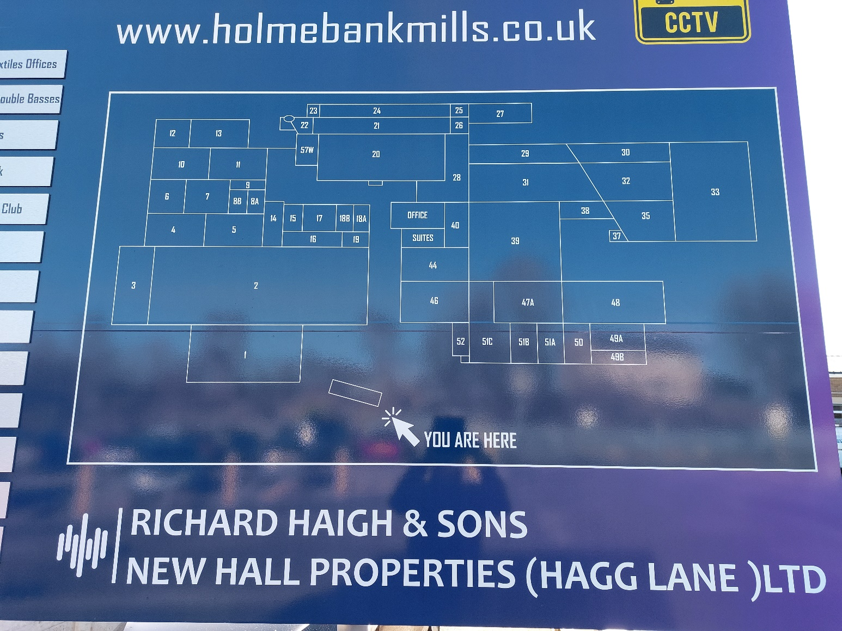

Plan showing the location of Unit 57W

There is a fire alarm system installed and maintained by the landlords for the entire industrial estate Unit 57W opens into a glass roofed yard space with a marked escape route to the left when exiting the unit. There is also a modified foam fire extinguisher point for tackling small fires and there is a fire alarm actuation point both on the exit route from the covered yard.

Potential sources of fire may include an electrical fault (there is a locked 3 phase supply cupboard in the unit and a distribution board on one wall with a small number of plug sockets.

There may be very small quantities of potentially combustible materials and substances in the unit including paper, lubricants (chain oil, GT85 spray cans) and wiping cloths.

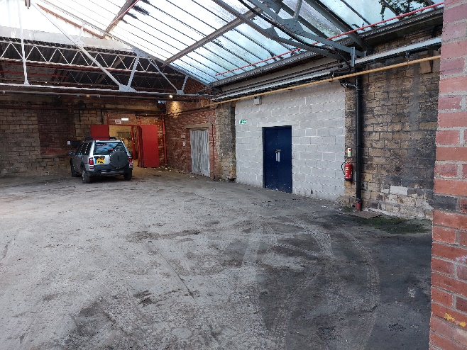 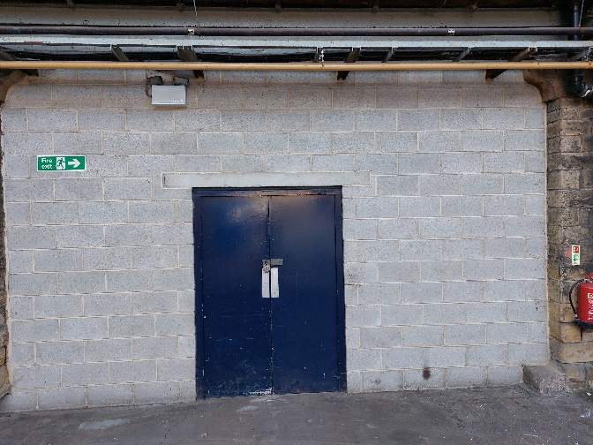

Unit 57W (blue door) opens into a glass covered yard. The escape direction is marked by running man signs indicating escape via the normal exit route that will be familiar to users.

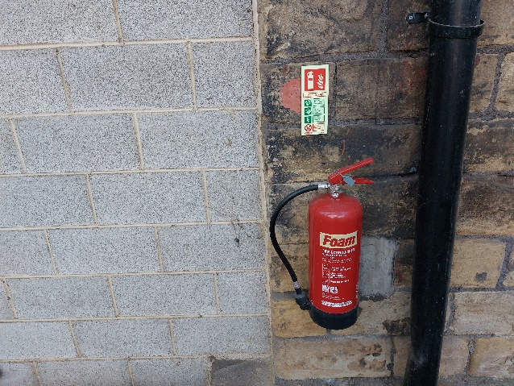 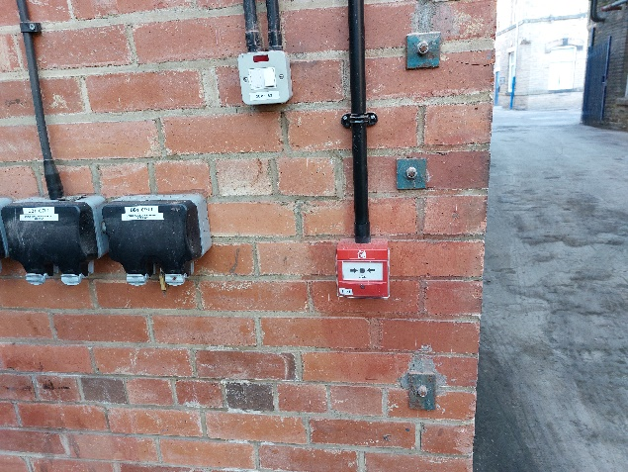

There is a modified foam fire extinguisher and a fire alarm actuation point close to the unit, on the escape route from the covered yard.

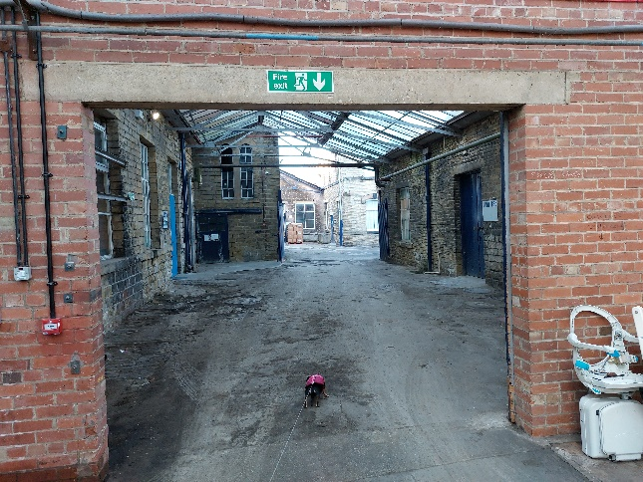 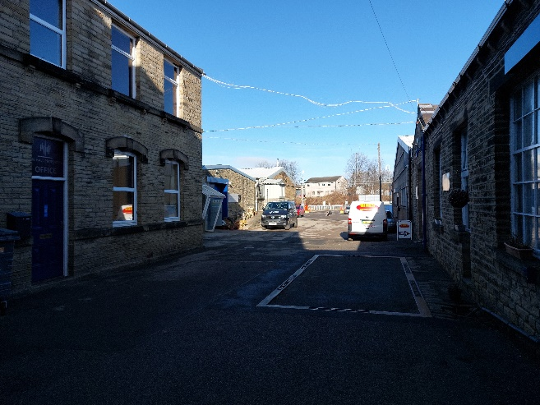

The escape route is signed through a further covered yard followed by a right turn once in the open air. Evacuation route continues along the yard in the direction of the car park at the site entrance.

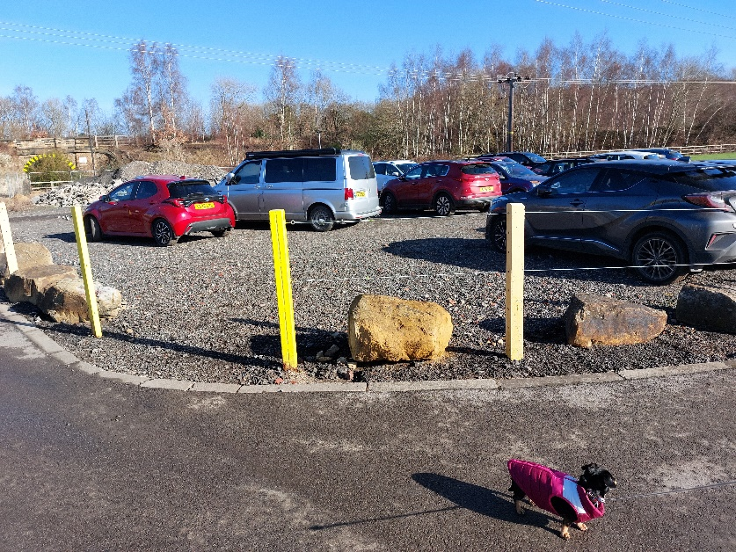

The assembly point is in the main car park at the entrance to the site

**Procedure:**

If the fire alarm sounds commence evacuation of the unit immediately.

In the case of a fire discovered in the unit shout ‘FIRE’ and ensure that all persons are directed towards the escape route.

Only a sighted person may attempt to use the fire extinguisher and only if the fire is very small.

If the fire alarm is not yet sounding a sighted person leaving the unit should press the fire alarm actuation button on the way out and telephone the emergency services once in a place of safety.

The designated ride leader and all participants will have a full list of names of participants for each event on the TT Logistics Whatsapp group and by email.

All stokers will either have sufficient sight to make their own way to the assembly point unaided or they will have a personal care plan and will be guided by a sighted pilot to the assembly point.

The ride leader on the day should ensure that every member is present and accounted for at the car park assembly point.

The fire service should be informed of anyone not accounted for.

**Training:**

All members will receive a brief induction on their first visit to the site, a printed copy of this procedure will be available on the site and at the beginning of each season all members will be reminded of this procedure before the first ride of the year.

This assessment completed by Stephen Butler on 23 February 2023. To be reviewed if any material change or annually (whichever is sooner)

T 07722 605055

E [reltubrs@gmail.com](mailto:reltubrs@gmail.com)