**Tandem Trekkers Route Assessment**

**Ride route: Spen Valley Greenway**

**OS Grid ref:- unavailable route plotted on Googlemaps**

The track is approximately 25 miles return from the tandem store at Hot Tub World according to Google maps.

**Note** This is a mixed path route with some sections on busy A roads with some multi carriageway stretches. There are some stretches on minor roads, but most is on paved greenway but at some points there are challenging “A” road traverses.

**Terrain**

Much of the route is flat but there are stretches with short hills that some may find taxing. The route is paved in its entirety with no gravel stretches.

**Other potential users of circuit or route (such as pedestrains, horses, cars etc):**

Leeds Rd is subject to heavy traffic of all types.

The greenway is shared with pedestrians and cyclists. There may be loose dogs.

**RIDE LEADER TO SCOPE EXTENT OF ACTUAL RIDE TO BE UNDERTAKEN.**

Date / details of route assessment :

24th May 2018 – Peter Hardy – route ridden on a solo hybrid with road tyres –entire section of ride taken comfortably at speed.

**Car parking / trailer parking notes:**

Cars may be parked in the Hot Tub World car park.

**Emergency exit**

There are trains every hour from Low Moor station in either direction. These may accept cycles [they tend to be pacer trains].

**Café**

There is a café on the trailside in Cleckheaton around 2.5 miles from Low Moor.

**Schedule of route / waymarks / particular hazards (points should appear on annotated map)**

|  |  |  |  |  |  |
| --- | --- | --- | --- | --- | --- |
| Nr | Grid ref | Distance from start  (miles) | Risk Description | Mitigation | Risk rating  Low / Med / High |
| START |  | 0 | Start point Hot Tub World. Ride starts on Whitacre St. use the pedestrian crossing to cross Whitacre St and establish a safe start position. When the lights turn green turn left onto Leeds Rd and proceed towards Huddersfield. | General care and caution | Med |
| 1 |  | .5m app | As the road climbs leave the bus lane and take up position in the RH filter lane and turn into the industrial estate. | General care and caution | Med / High |
| 2 |  |  | Take the road into the industrial estate and turn right at the bottom. Note there is no traffic precedence marked on the road surface. About 50yds after the turn is a path on the left. This is signed but parked vehicles and vegetation may make it difficult to spot. | General care and caution | Med / High |
| 3 |  | .5m app | Crossing of Bog Green Lane. This is a single carriageway road with fast moving traffic. Dismount to cross. | General care and caution | Med / High |
| 4 |  | .5m app | This stretch of greenway ends abruptly. Exercise caution turning into Helm Lane a broad single track road. | General care and caution | Med |
|  |  | .25m app | As the junction at the end of the lane begins to come into view there is an access style on the right that starts the next stretch of Greenway. This is signed but may be easy to miss. | General care and caution | Med |
|  |  | .25m app | There are pinch points at the summit over the railway bridge. It is possible for experienced riders to cycle through these. Less confident riders should dismount. | General care and caution | Med |
|  |  | .25m app | The greenway merges with Woodhead Rd. Turn left into Chadwick Lane and then take Calder Lane along the back of the river [do not cross the river]. | General care and caution | Med |
|  | POINT A | .25m app | At the Flowerpot pub T junction turn left onto Hopton Lane and bear right through the roundabout [do not cross the river] onto Granny Lane / Steanard Lane. | General care and caution | Med |
|  |  | 1m app | At the traffic lights it is advisable to dismount if the lights turn against the riders. Many riders find this hill start tricky and car users may be unsympathetic. This is a likely place for a rider to break a chain [or worse] through violent effort. Remount on the bridge allowing sight lines for motor vehicles approaching from the rear. | General care and caution. Dismount | High |
|  | POINT B | 100 yds app | At the junction turn left then first right, then immediately cross the road right to enter the park greenway route. This junction is busy. It is manageable for confident cyclists, but if in doubt dismount. Cycles may be wheel to the park junction and the crossing made on foot at that point. | General care and caution.  Dismount | High |
|  |  | 0.5 m app | Follow the road through the park until it merges with Bradbury St. There may be a barrier across the road. Dismount if necessary. Turn left into Myrtle Rd and continue onto Sackville St until Park Rd. This stretch contains junctions across bus routes and Sackville St, whilst continuous for cyclists does not read as a continuous route for motor vehicles. | General care and caution. Be aware of poor sight lines at start of path and exercise caution. | Med / High |
|  |  | .25m | Turn left onto park road and then stop and turn right onto the greenway track up to Dewsbury Moor. | General care and caution | Med |
|  |  | .25m | At the Greenway T-junction stop and turn left and proceed to Low Moor. This is continuous Greenway. Note there are some gated crossings. It is advisable to dismount at these points and wheel through rather than risk low speed falls. There is also a short road passage through a new housing development. This can be navigated safely using general observation and is not subject to high traffic densities or speeds. | General care and caution. Dismount | Med |
|  |  |  | Reverse route to return.  Other greenway observations: there is ramped access along the route and riders need to be aware of other users, in particular, runners, cyclists and dogs, approaching at occluded angles. | General care and caution | Med |

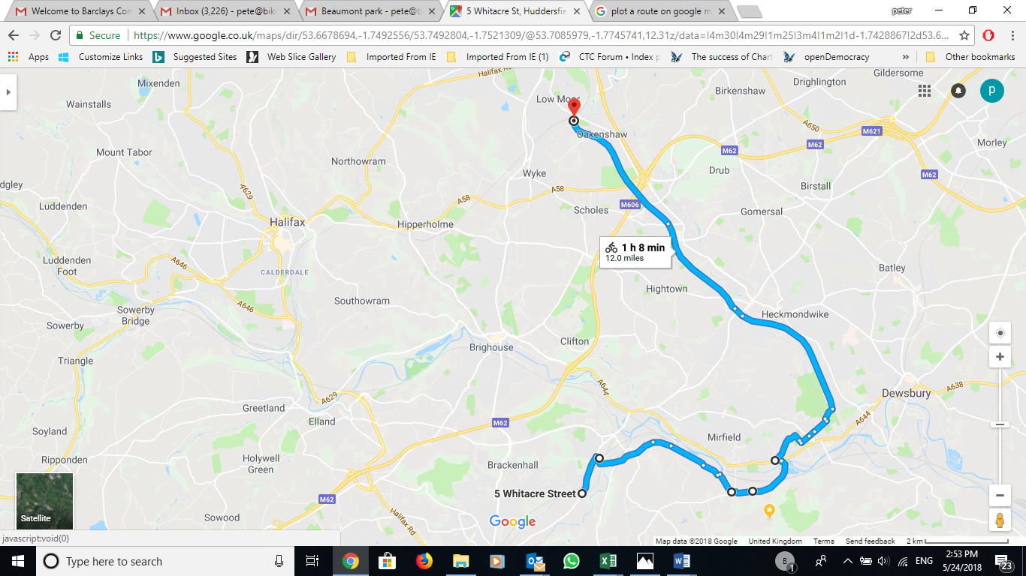

**Annotated map**

https://www.google.co.uk/maps/dir/53.6678694,-1.7492556/53.7492804,-1.7521309/@53.7085979,-1.7745741,12.31z/data=!4m30!4m29!1m25!3m4!1m2!1d-1.7428867!2d53.6756813!3s0x487bde867a26d65b:0x1e93265f5ca791ed!3m4!1m2!1d-1.6974545!2d53.6712154!3s0x487bdf032614efeb:0xc1b40faf18db08d9!3m4!1m2!1d-1.6940017!2d53.6682275!3s0x487bdf1b7ebb1de1:0xf5a9d770da28eb46!3m4!1m2!1d-1.6863989!2d53.6683572!3s0x487bdf107db33087:0xbe492f183d19b7ba!3m4!1m2!1d-1.6780755!2d53.6750402!3s0x487bdf0cf2c93863:0xbf7a6ed75259fa4d!1m0!3e1!4e1

**General risk assessment notes applicable to all rides**

* All riders should be encouraged to take part in activities that are within their capabilities.
* All riders must wear a helmet.
* High vis clothing to be considered for road riding
* The session leader should have checked the leader pack as per insert and have leader pack with them at all times. This must include first aid.
* Sun protection and water advisable to be carried.
* For exposed routes or winter rides suitable clothing is essential along with spare water or windproof items
* All ride leaders should familiarise themselves with the contents of the ride leader pack specifically tools, spares, first aid and survival equip.
* Ride leader should carry suitable navigation aids and check route assessment before commencing ride.

**Addendum – Paul Stark - Alternative Start**

**Ridden several times. Route assessed by PMS - 28 February 2019. Alternative first ridden with Trekkers 13 March 2019**

|  |  |  |  |  |  |
| --- | --- | --- | --- | --- | --- |
| Nr | Grid ref | Distance from start  (miles) | Risk Description | Mitigation | Risk rating  Low / Med / High |
| START |  | 0 | Start point Hot Tub World. Walk bikes ± 300 metres in NW direction up Whitacre Street using pavement to meet Birkby-Bradley Greenway (BBGW) Crossing Point. Join BBGW | General care and caution. Potential pavement trip hazards. Verbal guidance for walking VI’s | Low |
|  |  | ± 0.5m | BBGW crosses Deighton Road after ± 0.25 miles. Dismount and walk bikes across road and through barriers. Ride a further ± 0.25 miles to A62 and dismount before barriers. Join dedicated bus lane as described in Nr 1 of original assessment as above. | General care and caution crossing Deighton Road and when joining Bus Lane on Leeds Road | Low/Med |
|  |  |  |  |  |  |

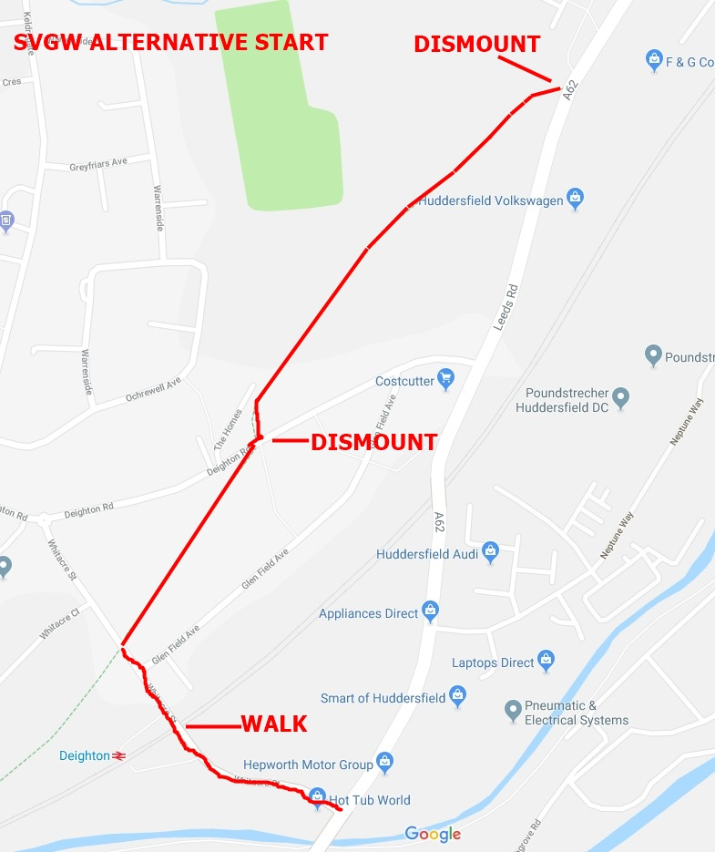

**Addendum – Paul Stark – Start from Holme Bank Mills**

**Route formally assessed by PMS - 22 February 2023 – Road Bike 700x28c – Weather Fine – Mixed cloud**

|  |  |  |  |  |  |
| --- | --- | --- | --- | --- | --- |
| Nr | Grid ref | Distance from start  (miles) | Risk Description | Mitigation | Risk rating  Low / Med / High |
| START |  | 0 | Start point Holme Bank Mills. |  |  |
|  |  | ± 0.05m | Through Pedestrian Gate to Right of Main Barrier. Gate is sufficiently wide to be cycled. | General care | Low |
|  |  | ± 0.15m | If main gate is closed – dismount, open pedestrian gate and walk. | General care | Low |
|  |  | ± 0.25m | Lane is unmade after Gill Bridge. It is quite cyclable but any tandem pairs unsure of surface to dismount and walk to Huddersfield Road | General care | Low |
|  |  | ± 0.45m | Huddersfield Road. Ride Leader to arrange for Junction to be marked so tandem pairs exiting Hurst Lane have opportunity to continue without dismounting if safe to do so. Otherwise, dismount walk across road and join dedicated cycle line | General care and observe pilot marking junction | Low/Med |
|  |  | ± 0.9m | Huddersfield Road / Church Lane Crossing – Calder Valley Greenway continues diagonally opposite junction. Ride Leader to arrange for Junction to be marked so tandem pairs can continue across bottom of Church Lane | General care and observe pilot marking junction | Low/Med |
|  |  |  | Route from this point route continues as above (POINT B). Recommended that on return tandems follow traditional route as assessed above and turn right at mini-roundabout into Station Road immediately before POINT A above. |  |  |