**Tandem Trekkers Route Assessment**

**Ride route: Stamford Bridge**

Route Assessed: 18th August 2022 – Paul Stark – Solo (700x28c). Weather Overcast 200c. Sections of route have previously been ridden on several occasions.

The route is largely on rural roads and quiet country lanes but includes two short +/- 250m sections on the busy A166. Approximately 1.0 mile is on an unbound surface necessitating extra care and vigilance. Some of the sealed surfaces are quite pot-holed.

Several lanes are particularly narrow and riders should be prepared to give way to oncoming vehicles and/or move over when followed by traffic wishing to overtake. There are a handful of well-marked passing places.

The route circumnavigates the town of Stamford Bridge, with plenty of turns/junctions. Riders will frequently encounter signs back to the town. Apart from when nearing the end, these directional signs are to be ignored. Keeping together on the ride is very important.

The total distance is 19 miles and includes 500’ of ascent / descent.

Being in a rural setting it is reasonable to encounter larger than normal agricultural vehicles which can be slow moving. Some lanes are also used by horse riders which should be passed slowly and widely when safe to do so and after giving a verbal alert to the rider.

|  |  |  |  |  |
| --- | --- | --- | --- | --- |
|  |  |  |  |  |
| Nr | Approx distance from start  (miles) | Risk Description | Mitigation | Risk rating  Low / Med / High |
| START | 0.0 | Start point – Viking Road Car Park, Stamford Bridge YO41 1BR |  |  |
| 1 | 0.3 | Right Turn into Old Station. Popular with pedestrians and dog walkers. Be prepared to give way to foot traffic | Extra care and vigilance | Low |
| 2 | 0.5 | Pinch Point / Gate. Use Gate on LHS if open to avoid dismounting. | Extra care and vigilance | Low |
| 3 | 3.0 | Unbound road/track surface | Extra care and vigilance | Low |
| 4 | 4.7 | Right turn into Eastfield Lane (narrow) on a slight incline. Ride Leader or appointee to mark junction | Extra care and vigilance | Low |
| 5 | 5.6 | Left turn on to busy A166 – followed by right turn | Extra care and vigilance. Use central filter lane when turning right. | Low - Med |
| 6 | 7.6 | Right turn – triangular junction – 2 x Give Way | Extra care and vigilance | Low |
| 7 | 9.1 | Slightly hidden right turn immediately before red brick wall | Extra care and vigilance | Low |
| 8 | 12.4 | Two river bridges at Buttercrambe. Give way to oncoming traffic. | Extra care and vigilance and be prepared to dismount if encountering traffic already crossing. |  |
| 9 | 12.5 | Right turn – triangular junction – 2 x Give Way | Extra care and vigilance | Low |
| 10 | 14.2 | Right turn on to busy A166 followed by left turn | Extra care and vigilance | Low-Med |
| 11 | 16.0 | Busy construction site – possibly under radio traffic and manual signal control | Follow instructions as appropriate | Low |
| 12 | 19.0 | END - Viking Road Car Park, Stamford Bridge YO41 1BR |  |  |

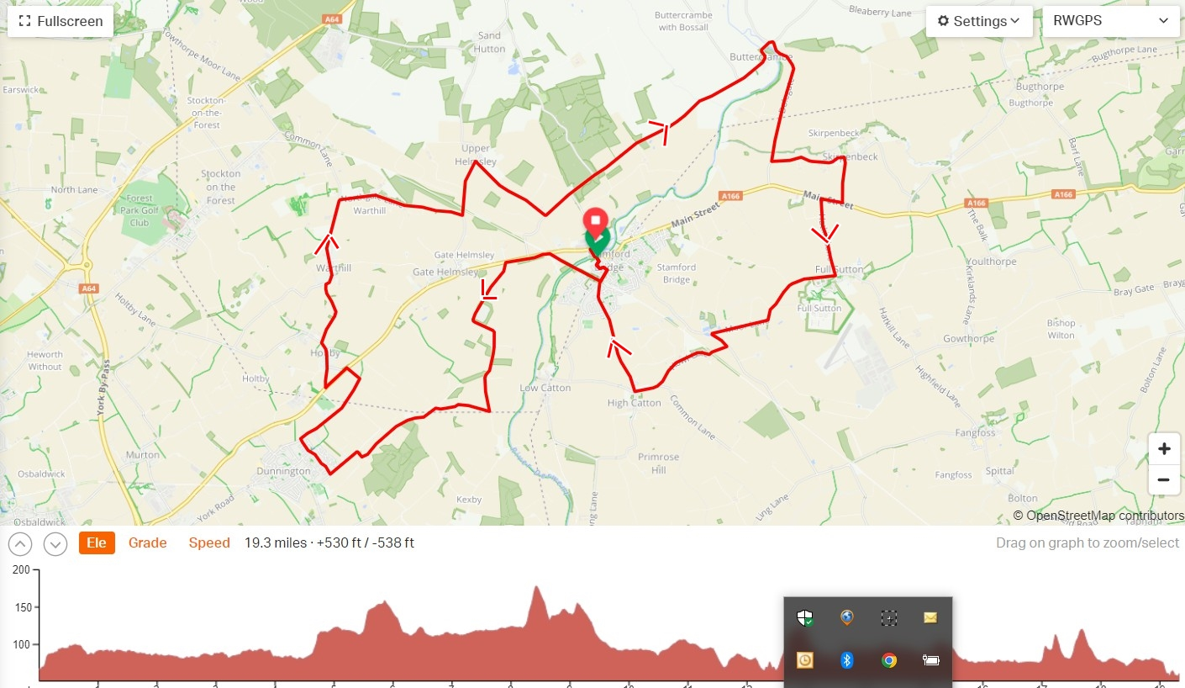

**General risk assessment notes applicable to all rides**

All riders should be encouraged to take part in activities that are within their capabilities.

All riders must wear a helmet.

High vis clothing to be considered for road riding.

The session leader should have checked the leader pack as per insert and have leader pack with them at all times. This must include first aid.

Sun protection and water advisable to be carried.

For exposed routes or winter rides suitable clothing is essential along with spare water or windproof items.

All ride leaders should familiarise themselves with the contents of the ride leader pack specifically tools, spares, first aid and survival equip.

Ride leader should carry suitable navigation aids and check route assessment before commencing ride.