**Tandem Trekkers Route Assessment**

**Ride route: Gargrave circular**

Route Assessed: Drew Mann drove this route by car Saturday 2 July 2022. (He has also cycled all these roads solo and on tandems many times in the past.)

The route is entirely on road and is mainly on quiet country roads but includes short sections on busier A - Roads

Being in a rural setting it is reasonable to encounter larger than normal agricultural vehicles which can be slow moving. Some lanes are also used by horse riders which should be passed slowly and widely when safe to do so and after giving a verbal alert to the rider.

I have chosen to ride this circuit in a clockwise manner as this means that the ride is not finishing up the steepest hill of the route!

The total ascent is only 1103 feet according to my ride generator in a distance of 23.69 miles.

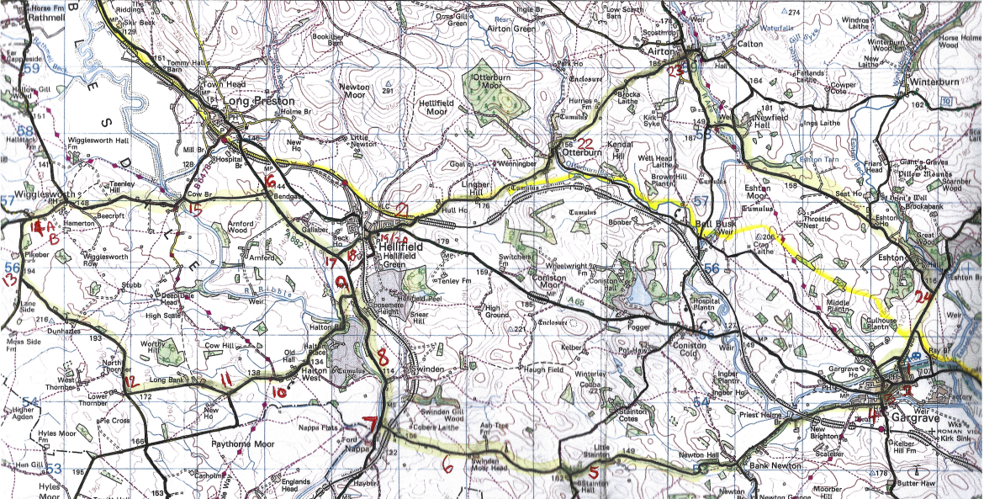

|  |  |  |  |  |
| --- | --- | --- | --- | --- |
|  |  |  |  |  |
| Map point  above | Approx. distance from start  (miles) | Risk Description | Mitigation | Risk rating  Low / Med / High |
|  | **0.0** | Start point – J D Tandems Asquith Industrial Estate, Unit 1 Cawood House, Gargrave, Skipton BD23 3SE |  |  |
| **1** | **0.10** | Exit from industrial estate and turn left onto Eshton Road | With flow of traffic. Minor road. Quiet | Low |
| **2** | **0.22** | T junction with A65. Turning right. This road can be busy but the site lines at this junction are good. | Tandem pairs should be prepared to dismount and walk bikes to crest | Medium |
| **3** | **0.47** | Follow main road through Gargrave looking for the left turn over the river bridge opposite the Dalesman café, signposted Broughton 2 and Station | Right turn from main road | Low/medium |
| **4** | **0.57** | Right turn at the junction by the Masons Arms (Marton Road) not signposted. Follow this road for 2.5 miles through Bank Newton. | This road is fairly quiet but you are turning across any potential oncoming traffic | Low/medium |
| **5** | **3.78** | Junction at Stainton Hall turn right by right turn sign, an uphill turn. Follow this road up uphill to Swinden Moor head and the descent to main road at Nappa | This road is fairly quiet but you are turning across any potential oncoming traffic | Low/medium |
| **6** | **5.71** | This is steep descent with a junction at the bottom where you need to stop | Not too bad surface-wise | Medium/high |
| **7** |  | Junction with A682 – main road but not terribly busy. Right turn which is slightly downhill and sightlines are good | Main road with a short climb but reasonably wide and visibility good | Low/medium |
| **8** | **7.03** | Continue on A682 for 1.32 miles to left turn signposted as Halton West/Bolton by Bowland |  | Low/medium |
| **9** |  | Left turn from main road. Downhill to bridge and then back up again | Care on descent. |  |
| **10** |  | Follow this road through Halton West up to Long Bank |  |  |
| **11** | **8.78** | Take first right signed for Wigglesworth. The view forwards here is not good so take extra care | This road is fairly quiet but you are turning across any potential oncoming traffic | Low/medium |
| **12** | **9.76** | T junction unsigned - turn right. Sightlines good | This road is fairly quiet but you are turning across any potential oncoming traffic | Low/medium |
| **13** | **11.39** | T junction - turn right signed Wigglesworth/Settle. Sightlines good. | This road is fairly quiet but you are turning across any potential oncoming traffic | Low/medium |
| **14A** | **11.93** | As you approach the next junction the village community hall where the café stop is to be is on your left so slow and be prepared to turn in to their carpark | Lunch! |  |
| **14B** | **11.96** | T junction turn right signed Long Preston B6478 -. View to left not too good. | Care at junction and watch for the hall. | Low/medium |
| **15** | **13.53** | Follow the B6478 through the village and down to the bridge over the river where turn right signed “Unsuitable for HGVs” | This road is fairly quiet but you are turning across any potential oncoming traffic | Low/medium |
| **16** | **14.32** | Road climbs to T junction with A682. The exit is between buildings and you will need to stop to get a clear view of traffic before proceeding and turning right. (No sign post) | Main road but not usually too busy and sightlines reasonable once stopped | Low/medium |
| **17** | **15.2** | Follow the main road for .88 miles - you climb up and then there will be a left turn into an unsigned minor road just after a 40 sign. | Left turn might be difficult to see. Keep an eye out at the 40 sign |  |
| **18** |  | This road is very minor at the turn end and is quite rough and seems like a track but it is a road and does open out and improve as you approach Hellifield village. |  | Low/medium |
| **19** | **15.58** | Turn left at end of minor road after passing under the railway bridge giving way to any traffic to your right | This road is fairly quiet but you are turning across any potential oncoming traffic | Low/medium |
| **20** | **15.64** | This road is then quickly at a T junction with the A65 where you will need to take care to turn right. | Main road but not usually too busy and sightlines reasonable once stopped. Speed limit 30 as in village | Low/medium |
| **21** | **15.84** | Follow main road for 0.2 miles and turn left before the hill by the 40 sign signposted Airton/Malham |  |  |
| **22** | **17.7** | Follow this road for 1.86 miles to Otterburn village. Go through the village and over the bridge SP Airton/Malham |  |  |
| **23** | **19.27** | Airton village T junction where turn right signed Bell Busk/Gargrave | This road is fairly quiet but you are turning across any potential oncoming traffic | Low/medium |
| **24** | **22.82** | Follow the road to the bridge and cross and keep on this road to Eshton and junction with signpost Gargrave 11/2 miles. | Your right of way but watch for traffic on road to left. | Low/medium |
| **1** | **23.68** | Continue on this road over the canal bridge and turn left back into the industrial estate |  |  |
|  | END | Asquith Industrial Estate – JD Tandems shop |  |  |