**Tandem Trekkers Route Assessment - Ride route: Hull to Hornsea**

**INTRODUCTION**

This ride is led by Beech Holme Tandem Club [Sight Support | Beech Holme Tandem Club](https://www.sightsupport.org/services/clubs-and-groups/beech-holme-tandem-club) and has been successfully ridden by Tandem Trekkers on two previous occasions.

The route was further ridden by Paul Stark, John Tayler and Charles Williams on 21st March 2022. Weather: 10o C. Sunny and Calm. Ridden on solo road/hybrid bikes fitted with 700c x 25/28 Tyres

Most of the route follows the old Hull to Hornsea Railway Line (Trans Pennine Trail Route 65). [Hornsea Rail Trail (Hull to Hornsea) - Sustrans.org.uk](https://www.sustrans.org.uk/find-a-route-on-the-national-cycle-network/hornsea-rail-trail-hull-to-hornsea) The track is 57.5% asphalt and 42.5% unsealed and is 13 miles long but the last 1.0 mile into Hornsea is not ridden.

The route is essentially flat with less than 300’ of ascent which, given the distance, is hardly noticeable.

However, sections of the trail are exposed and, given the overall distance of 28 miles, and the road traffic sections, this ride is deemed suitable for experienced Trekkers only.

**GENERAL HAZARDS**

General hazards are the sections on busy roads and on the actual trail uneven surfaces due to tree roots, mud patches following inclement weather, pedestrians (popular with dog walkers) and other cyclists. Loud and clear verbal instructions/bell ringing when approaching and passing other trail users need to be used. Dogs and young children can be unpredictable!

In wet weather the track can be a little difficult in the unmade sections – but such sections are short and walkable if really necessary

A number of minor roads and one busy main road (A165) are crossed as detailed below. At each side of all road crossings are "z" type barriers which are very difficult to negotiate by tandem without both riders getting off and walking through and walking across the roads. Dismounting to cross the A165 is deemed essential

**GENERAL MITIGATION OF RISK (AS SUPPLIED BY BEECH HOLME TANDEM CLUB)**

We will be riding in accordance with our standard procedures. We will have a lead tandem and a back marking tandem. Everyone else will be sandwiched between these two. Both lead and back tandem riders will be wearing orange tabards and will be carrying radios. A first aid kit will be carried by one of our tandems (also carrying a radio) in the middle of the pack.

We will be supported by a Sight Support (Hull and East Riding) mini bus driven by one of our members which will also be carrying a radio and a first aid kit, The mini bus will meet us at the road crossing points (where it is safe to do so). The mini bus will also be carrying tools, a spare front and rear wheel and will have the facility to carry one tandem should this be necessary (should an en route repair not be possible or if any back riders are having difficulties etc.).

**NOTED RISKS**

|  |  |  |  |  |
| --- | --- | --- | --- | --- |
|  |  |  |  |  |
| **Nr** | **Approx distance from start (miles)** | **Risk Description** | **Mitigation** | **Risk rating**  **Low / Med / High** |
| START | 0.0 | Start point – Beech Holme Court Beverley Rd, Hull HU5 1NF |  |  |
| 1 | 0.0 – 1.75 | Route to the start of the TPT follows busy roads including the A1079 and includes several turns, roundabouts and road junctions. It can be very busy. | Extra care and vigilance... Please see additional general mitigation provided by Beech Holme above. Junctions to be marked where safe and appropriate. Cycle lanes to be used where present | Med |
| 2 | 1.75 - 6.8 | Several minor roads cross the trail. | Recommended for riders to dismount and walk across roads | Low |
| 3 | 6.8 | Trail crosses busy A165 | Compulsory dismount to cross road | Low |
| 4 | 6.8 – 13.4 | Surface is unsealed and subject to minor ponding and rutting through short muddier parts of track | Extra care and vigilance. Endeavour to cycle on drier parts of trail. If in doubt ride leader to instruct riders to dismount and walk. | Low |
| 5 | 8.4 | Short but tricky ascent to cross road includes two sharp s-bends | Riders to dismount and walk tandem up hill and over road |  |
| 6 | 13.4 – 13.8 | Quiet residential roads including turns and a roundabout | Extra care and vigilance | Low |
| END | 13.8 | Whiteheads Fish and Chip Shop Hornsea HU18 1SL |  |  |

**ROUTE MAP AND TOPOGRAPHY**

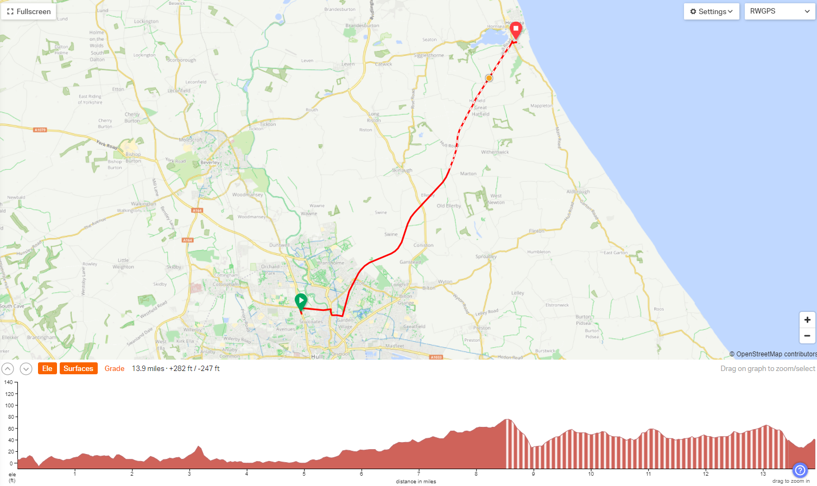

**General risk assessment notes applicable to all rides**

All riders should be encouraged to take part in activities that are within their capabilities.

All riders must wear a helmet.

High vis clothing to be considered for road riding.

The session leader should have checked the leader pack as per insert and have leader pack with them at all times. This must include first aid.

Sun protection and water advisable to be carried.

For exposed routes or winter rides suitable clothing is essential along with spare water or windproof items.

All ride leaders should familiarise themselves with the contents of the ride leader pack specifically tools, spares, first aid and survival equip.

Ride leader should carry suitable navigation aids and check route assessment before commencing ride.