**Tandem Trekkers Route Assessment**

**Ride route: North Wales Coast Path – Prestatyn to Colwyn Bay**

**OS Grid ref:- SJ 057 836 to SH 852 791**

Approx route/circuit length: 14 miles of North Wales Coast Path with refreshments available at the middle / turning point in Colwyn Bay and return on same route.

**Note** A popular coastal path that proves interesting in the off season.

**Terrain**

This is a Sustrans National Cycle Netwrok trail, it is almost entirely tarmac and concrete surfaced paths. With the exception of a number of minor road crossings it is entirely traffic free but well used by walkers, dog walkers and cyclists. This is an exposed coastal path along the Irish Sea Coast of North Wales it is generally flat apart from two sections elevated above sea level by sudden sharp climbs / descents as noted below.

**Other potential users of circuit or route (such as pedestrains, horses, cars etc):**

This trail is reasonably popular with families, mobility scooters, bikes and dog walkers so expect to meet people / animals and other cyclists.

**RIDE LEADER TO SCOPE EXTENT OF ACTUAL RIDE TO BE UNDERTAKEN.**

Date / details of route assessment :

10th September 2016 - Barney Harle – route ridden on a solo recumbent on a busy Sunday afternoon – total time for 28 miles – 3hours including refreshment stop and ice cream in Colwyn Bay.

**Car parking / trailer parking notes:**

There are various options in Prestatyn and Rhyll but these need further research as the risk assessment was started from an inland position as part of a wider ride.

**Schedule of route / waymarks / particular hazards (points should appear on annotated map)**

|  |  |  |  |  |  |
| --- | --- | --- | --- | --- | --- |
|  |  |  |  |  |  |
| Nr | Grid ref | Miles from start | Risk Description | Mitigation | Risk rating  Low / Med / High |
| START | SJ 057 836 | 0 | Start point Prestatyn beachside café’s |  |  |
| 1 | SH 996 808 | 4.3 | Footbridge to beach path | Requirement to change direction and ride across a pedestrian feature bridge with bollards and pedestrian traffic.  Ask group to reduce speed, be aware of other users, if necessary stop and walk across bridge | Low |
| 2  3 | SH 976 801  SH 966 801 | 5.7  6.4 | Path splits, cyclists take inland route, pedestrians proceed via steps to coastal edge.  Ditto as paths re-merge | Cyclists need to manoeuvre away from steps and follow appropriate path avoiding steps  Reduce speed, ride leader consider parking to guide point correct route | Low |
| 4 | SH 945 787 | 8.1 | Road crossing at Abergele Railway Station | General care and caution at relatively minor and obvious junction | Low |
| 5 | SH 908 786 | 10.0 | Path goes across narrow footbridge | Cyclists need to manoeuvre across narrow wooden bridge  Reduce speed, ride leader consider group walking this one if very busy | Low - Med |
| 6 | SH 896 784 SH 887 786 SH 876 787 SH 870 787 | 11.0 – 12.4 | Path rises steeply above normal sea level route for 2 short sections before descending back to sea level, this achieved by means of 4 very sharp, quite short climbs / descents of 10% or greater gradient. With care and good co-ordination they can be ridden but a midway stop or traffic may present difficulties for stopping dismounting | Cyclists need to manoeuvre up / down very steep gradients in excess of 10%.  Before inclines decide to walk or ride – this is for each pairing to decide in conjunction with ride leader  Before climbs engage very low gear or get off and walk  Before descents check riders are content, check for traffic, reduce speed to walking pace, consider use of drag brake if fitted, or consider walking. | MEDIUM + |
| END | SH 852 791 | 14.0 | Turn around on prom at Colwyn Bay |  |  |

**GENERAL WARNING** - Exposed coastal route

This is an exposed coastal route and the danger of people suffering hypothermia if the weather is poor or changes suddenly must not be underestimated. All riders need to be aware of the risk and suitable clothing needs to be considered. Also due to its coastal location be aware of wind as an asses issue.

In the event of group members exhibiting early signs of hypothermia early preventative action is essential.

DO NOT PUSH ON REGARDLESS – CONSIDER OPTIONS CAREFULLY!

**Annotated map**

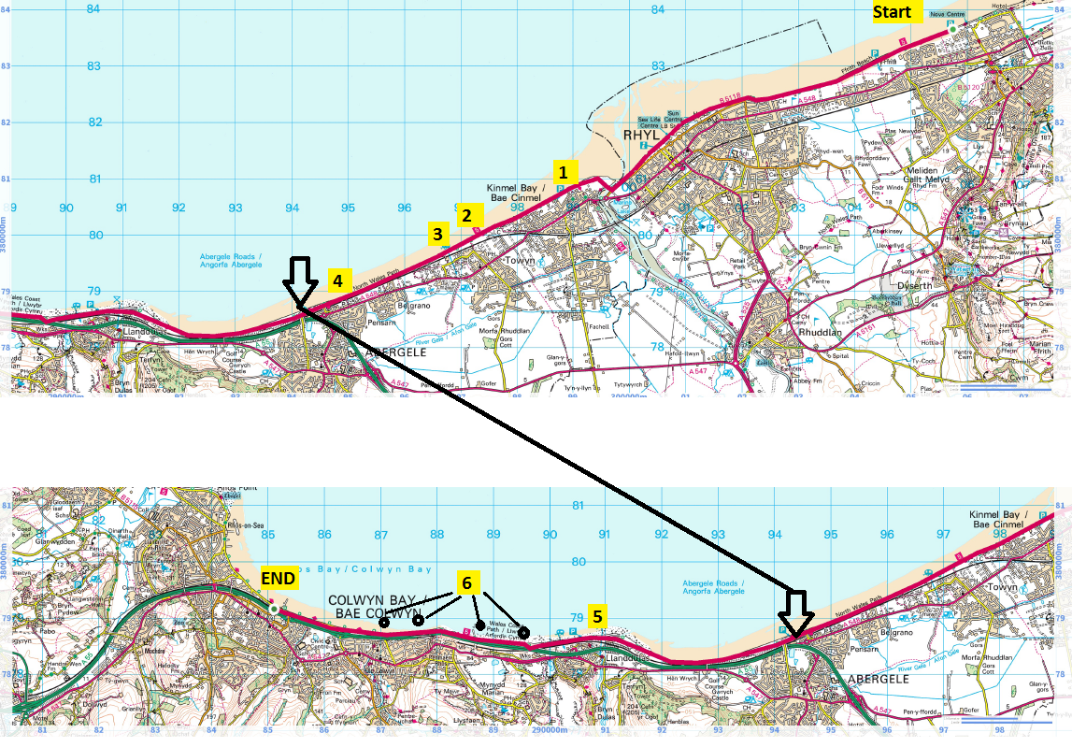

**General risk assessment notes applicable to all rides**

* All riders should be encouraged to take part in activities that are within their capabilities.
* All riders must wear a helmet.
* High vis clothing to be considered for road riding
* The session leader should have checked the leader pack as per insert and have leader pack with them at all times. This must include first aid.
* Sun protection and water advisable to be carried.
* For exposed routes or winter rides suitable clothing is essential along with spare water or windproof items
* All ride leaders should familiarise themselves with the contents of the ride leader pack specifically tools, spares, first aid and survival equip.
* Ride leader should carry suitable navigation aids and check route assessment before commencing ride.

**Rider information form**

**Ride**

**Date**

**Ride leader**

|  |  |  |  |  |  |
| --- | --- | --- | --- | --- | --- |
| Name | Pilot / stoker | Level of visual impairment | Contact number on day | Emergency contact | How travelling to ride |
|  |  |  |  |  |  |
|  |  |  |  |  |  |
|  |  |  |  |  |  |
|  |  |  |  |  |  |
|  |  |  |  |  |  |
|  |  |  |  |  |  |
|  |  |  |  |  |  |
|  |  |  |  |  |  |
|  |  |  |  |  |  |
|  |  |  |  |  |  |
|  |  |  |  |  |  |
|  |  |  |  |  |  |