**Tandem Trekkers Route Assessment**

**Ride route: Manifold Trail – Waterhouses to Hulme End**

**OS Grid ref:- SK 084 501 to SK 103 593**

Approx route/circuit length: 8 miles of well surfaced cycle path and very minor roads that take riders on a novel track through a deep sheltered gorge with a village at the head of the trail including a tea hut and pub. Opportunities to add to the Northern end of the trail with B roads and other areas if people want to explore options at a later date.

**Terrain**

The route is all reasonably gentle gradients with good surface but one tunnel which may be disconcerting to raw beginners but are generally not problematic.

**Other potential users of circuit or route (such as pedestrains, horses, cars etc):**

This trail is popular with tourists, families and dog walkers so expect to meet people / animals and other cyclists.

Certain parts are mixed use minor roads so beware of traffic

**RIDE LEADER TO SCOPE EXTENT OF ACTUAL RIDE TO BE UNDERTAKEN.**

Date / details of route assessment :

27th January 2017 - Barney Harle – route ridden on a solo upright on a quiet weekday winter morning with sub zero temperatures – total time for 17 miles – under 2 hours including a quick coffee from flask no formal stop as such

**Car parking / trailer parking notes:**

Recommend parking at well signed car park at Waterhouses.

**Schedule of route / waymarks / particular hazards (points should appear on annotated map)**

|  |  |  |  |  |  |
| --- | --- | --- | --- | --- | --- |
|  |  |  |  |  |  |
| Nr | Grid ref | Distance from start  (miles) | Risk Description | Mitigation | Risk rating  Low / Med / High |
| 1 | SK 084 501 | Start | Initially leaving car park route is well signed but can be soft and muddy before joining footpath adjacent main road | Brief riders before leaving. | Low |
| 2 | SK 091 501 | 0.5 | MAJOR ROAD CROSSING – A52 – this is a busy road and pairings need to decide whether to ride or dismount and walk. Good visibility and perpendicular with good run off after crossing so opportunity to ride safely. | Ride leader to ensure all riders cross safely and consider posting sentries. | MED |
| 3 | SK 100 542 | 3.5 | Trail crosses a very minor B road via gates on the path. Consider posting people to manage gates. | General care and caution. | Low |
| 4 | SK 098 557 to SK 091 578 | 5.2 – 6.5 | Trail shares its route with a very minor B road, this road is of a very minor nature, single track and only used by local traffic | Be aware of likelihood of traffic and keep single file where necessary pulling over to allow traffic to pass | Low |
| 5 | SK 091 578 | 6.5 | The road section of the ride culminates in an illuminated tunnel | No issues but cyclists need to be aware of possible traffic | Low |
| 6 | SK 095 584 | 7.5 | Trail crosses a very minor B road via gates on the path. Consider posting people to manage gates. | General care and caution. | Low |
| 7 | SK 103 593 | 8.5 | Village roads – if the midway refreshment stop is to be the pub it is approx. 300m to the east of the Hulme End station tea shop and this section will need to be ridden on local minor roads | General care and caution. | Low |

**GENERAL WARNING** - Popular tourist route

There is likely to be other traffic but this is a wide route offering potential for a pleasant ride in novel circumstances.

**Annotated map**

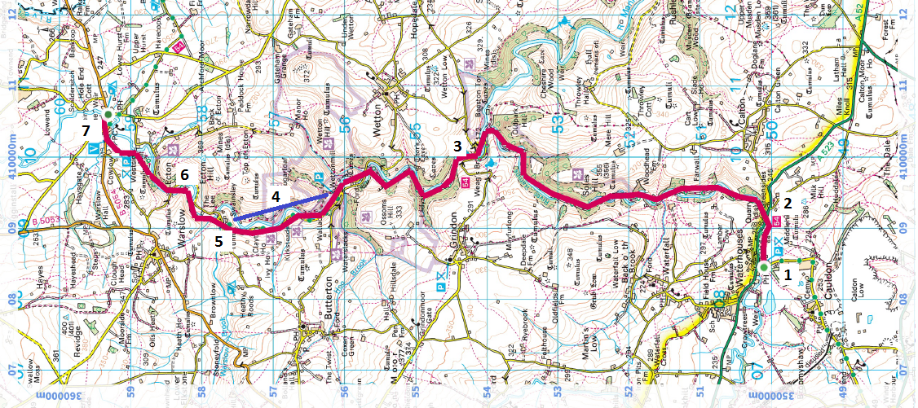

**General risk assessment notes applicable to all rides**

* All riders should be encouraged to take part in activities that are within their capabilities.
* All riders must wear a helmet.
* High vis clothing to be considered for road riding
* The session leader should have checked the leader pack as per insert and have leader pack with them at all times. This must include first aid.
* Sun protection and water advisable to be carried.
* For exposed routes or winter rides suitable clothing is essential along with spare water or windproof items
* All ride leaders should familiarise themselves with the contents of the ride leader pack specifically tools, spares, first aid and survival equip.
* Ride leader should carry suitable navigation aids and check route assessment before commencing ride.

**Rider information form**

**Ride**

**Date**

**Ride leader**

|  |  |  |  |  |  |
| --- | --- | --- | --- | --- | --- |
| Name | Pilot / stoker | Level of visual impairment | Contact number on day | Emergency contact | How travelling to ride |
|  |  |  |  |  |  |
|  |  |  |  |  |  |
|  |  |  |  |  |  |
|  |  |  |  |  |  |
|  |  |  |  |  |  |
|  |  |  |  |  |  |
|  |  |  |  |  |  |
|  |  |  |  |  |  |
|  |  |  |  |  |  |
|  |  |  |  |  |  |
|  |  |  |  |  |  |
|  |  |  |  |  |  |