**Tandem Trekkers Route Assessment**

**Ride route: Leeds Rd Greenway**

**OS Grid ref:- unavailable route plotted on Googlemaps**

The track is approximately 4 miles return from the tandem store at Hot Tub World according to Google maps.

**Note** This is a mixed path route with some sections on or crossing minor roads, but most is on paved greenway.

**Terrain**

Much of the route is flat but there are stretches with very short hills that some may find taxing. The route is paved in its entirety with no gravel stretches.

**Other potential users of circuit or route (such as pedestrains, horses, cars etc):**

The greenway is shared with pedestrians and cyclists. There may be loose dogs.

**RIDE LEADER TO SCOPE EXTENT OF ACTUAL RIDE TO BE UNDERTAKEN.**

Date / details of route assessment :

24th May 2018 – Peter Hardy – route ridden on a solo hybrid with road tyres –entire section of ride taken comfortably at speed.

**Car parking / trailer parking notes:**

Cars may be parked in the Hot Tub World car park.

**Brewery**

There is a brewery at the end of the Greenway in Huddersfield.

**Schedule of route / waymarks / particular hazards (points should appear on annotated map)**

|  |  |  |  |  |  |
| --- | --- | --- | --- | --- | --- |
| Nr | Grid ref | Distance from start  (miles) | Risk Description | Mitigation | Risk rating  Low / Med / High |
| Start |  | 0m | Turn left onto Whitacre St and proceed past the station to the start of the Greenway on the LH side of the road. As this is a hill start some riders may prefer to push or start on the railway bridge to avoid mechanical overstress to the cycle. | General care and caution | Med |
|  |  | .25m | Turn left onto the Greenway. | General care and caution | Med |
|  |  | 1m | Turn into Topaz close / Aquamarine Drive then proceed directly forward to continue on the Greenway. | General care and caution | Med |
|  |  | 1m | The greenway ends suddenly with a steep switchback descent. It is advisable for Tandem Riders to dismount at this point at this turns may be too severe to manage. Be aware the Greenway runs onto a footpath and excessive speed may be accrued on the descent by the unwary. | General care and caution.  Dismount | Med / High |
|  |  | 0.1m | Remount on Willow Lane and turn right out of the Greenway the Brewery is on the left. | General care and caution | Med |

**Annotated map**

­­­­­­­­

https://www.google.co.uk/maps/dir/53.6678694,-1.7492556/Magic+Rock+Brewing+Co.+Ltd,+Willow+Lane,+Huddersfield/@53.6628439,-1.7860672,14z/am=t/data=!4m10!4m9!1m0!1m5!1m1!1s0x487bdc95cd02536f:0x901384daf5099f54!2m2!1d-1.7870763!2d53.6560768!3e1!4e1

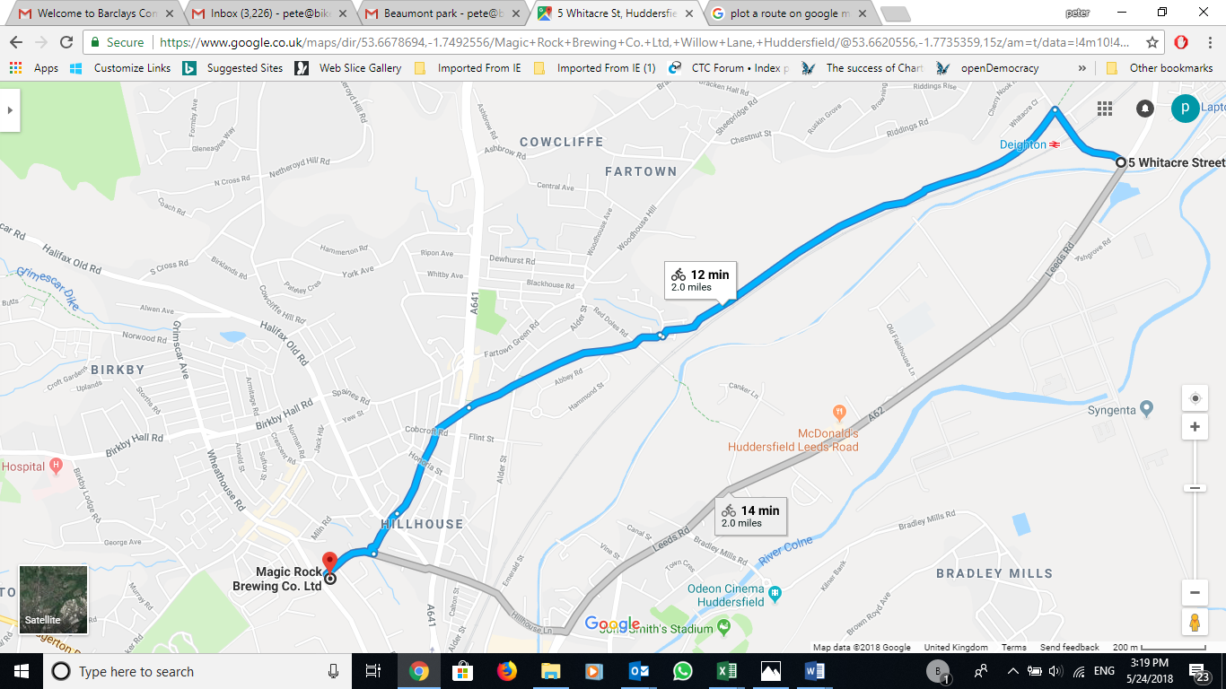

**General risk assessment notes applicable to all rides**

* All riders should be encouraged to take part in activities that are within their capabilities.
* All riders must wear a helmet.
* High vis clothing to be considered for road riding
* The session leader should have checked the leader pack as per insert and have leader pack with them at all times. This must include first aid.
* Sun protection and water advisable to be carried.
* For exposed routes or winter rides suitable clothing is essential along with spare water or windproof items
* All ride leaders should familiarise themselves with the contents of the ride leader pack specifically tools, spares, first aid and survival equip.
* Ride leader should carry suitable navigation aids and check route assessment before commencing ride.