Tandem Trekkers Route Assessment

Ride route: Fairburn Loop 2

Route Assessed: The route was ridden and assessed as an extended version of the original route; by Keith Sandiford and Charles Williams on Wednesday 10th November 2021. The route is entirely on road and is mainly on quiet country roads

There are some level crossings on this route. Ride slowly (but not so slow as to affect balance, and always with enough speed to freewheel across if necessary) over these, when barriers and lights (if applicable) show safe to do so.

After the bridge over the M62 at 5.6km, and for the next 2km, the route passes through an area where quarries are occasionally active. Take extra care when there is mud on the road and be alert to the possibility of quarry vehicles causing obstruction.

The extra additional part of this route is the first 25km, after which it joins Fairburn Loop 1 at its 15km distance. On this newly Risk Assessed section all junctions have clear line of sight for a considerable distance in both directions and are deemed as minimal risk.

Being in a rural setting it is reasonable to encounter larger than normal agricultural vehicles which can be slow moving. Some lanes are also used by horse riders which should be passed slowly and widely when safe to do so and after giving a verbal alert to the rider.

General Caution and alertness should be exercised at all times.

Nr | Approx distance from start  (km) | Risk Description | Mitigation | Risk rating  Low / Med / High
START | 0.0 | Start point – Birkin Fisheries, Haddlesey Rd, Birkin, Knottingley WF11 9LT
1 | 1.9 | Bridge over River Aire – Slight incline and narrowing of lane – no side verge. Possible oncoming traffic on bridge which cannot be seen on approach | Extra care and vigilance | Low
2 | 3.4 | Right turn onto Weetland Rd. Slightly busier road. | Normal Care and attention. Good visibility in both dirrections | Low
3 | 5.6-7.6 | Possibility of mud on road and quarry vehicles | Slow down and take extra care | Low
3 | 34.5 | Route re-crosses A19. Fast moving traffic and restricted view to south. Mandatory STOP sign | Extreme care. All bikes to approach junction slowly and STOP. Mark junction and proceed when safe. Ride Leader or nominee to supervise crossing. | High
4 | 34.6 | Congestion risk at re-group point after crossing A19. Stop away from junction and parked cars on Millfield Lane | Ensure bikes are stopped away from junction and adequate clearance for other road users maintained | Low
5 | END 39.3 | End point – Birkin Fisheries, Haddlesey Rd, Birkin, Knottingley WF11 9LT

Route and Route Profile

Distance: 39.3km
Elevation Gain: 155mtr
Elevation Loss: 155mtr
Maximum upward gradient 2.7%
Maximum downward gradient 2.2%

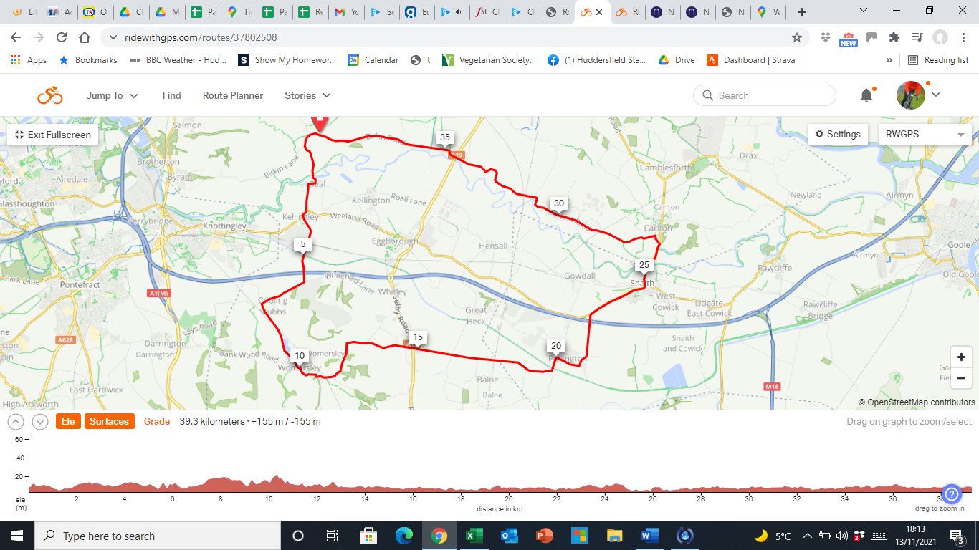

General risk assessment notes applicable to all rides

All riders should be encouraged to take part in activities that are within their capabilities.

All riders must wear a helmet.

High vis clothing to be considered for road riding.

The session leader should have checked the leader pack as per insert and have leader pack with them at all times. This must include first aid.

Sun protection and water advisable to be carried.

For exposed routes or winter rides suitable clothing is essential along with spare water or windproof items.

All ride leaders should familiarise themselves with the contents of the ride leader pack specifically tools, spares, first aid and survival equip.

Ride leader should carry suitable navigation aids and check route assessment before commencing ride.

