**Tandem Trekkers Route Assessment**

**Ride route: Boroughbridge – 25 miles**

**Route Assessed:** Route assessed 5th August 2021 by Paul Stark.

**Weather:** Dry. Light Winds. 20c.

Route is 25 miles including less than 500’ ascent on country lanes and quiet rural roads. The only material hazard (Medium Risk) is Aldwick Toll Bridge.

Being in a rural setting it is reasonable to encounter larger than normal agricultural vehicles which can be slow moving. Some lanes are also used by horse riders which should be passed slowly and widely when safe to do so and after giving a verbal alert to the rider.

**ELEVATION PROFILE**

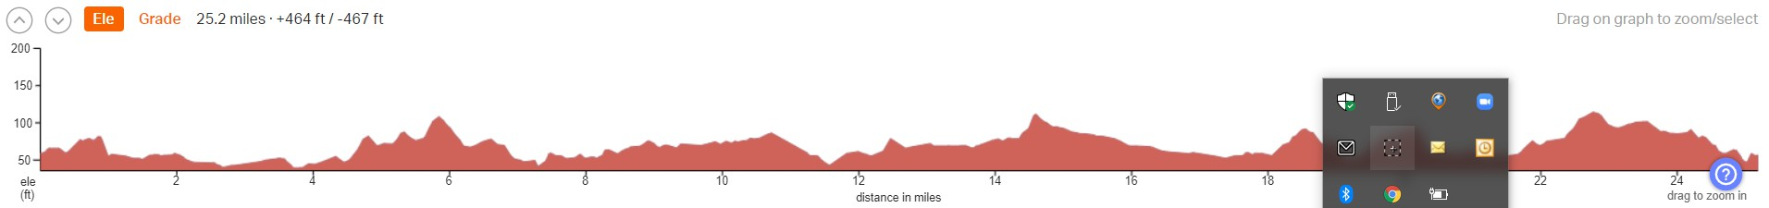

|  |  |  |  |  |
| --- | --- | --- | --- | --- |
|  |  |  |  |  |
| Nr | Approx distance from start  (miles) | Risk Description | Mitigation | Risk rating  Low / Med / High |
| START | 0.0 | Start point – Back Lane Car Park, Borougbridge |  |  |
| 1 | 100 metres | Route turns left into York Road. On very slight gradient. | Mark junction and if safe, convenient and appropriate, ride leader or appointee to stop traffic allowing tandems to join road without stopping. | Low |
| 2 | 7.2 miles | Aldwick Toll Bridge. A narrow rickety toll bridge with wooden surface. | Ride Leader to confirm surface is not slippery and safe to cycle. Otherwise, compulsory dismount and walk. Tandems not to attempt crossing if any on-coming vehicles. | Medium |
| 3 | 18.9 miles | Thornton Bridge. Narrow. On-coming vehicles have right of way | Observe Giveway sign and do not cross if on-coming traffic. | Low |
| 4 | 19.0 miles | Risk of taking left turn marked “Boroughbridge”. Whilst this is the most direct route back to the start point it is busier than the actual route which adds an additional 2.0 miles. | Mark Junction until last bike has seen route continues. | Low |
| 5 | 24.6 miles | Enter Boroughbridge and expect slow moving and reasonable volumes of traffic. | Extra care and vigilance. | Low |

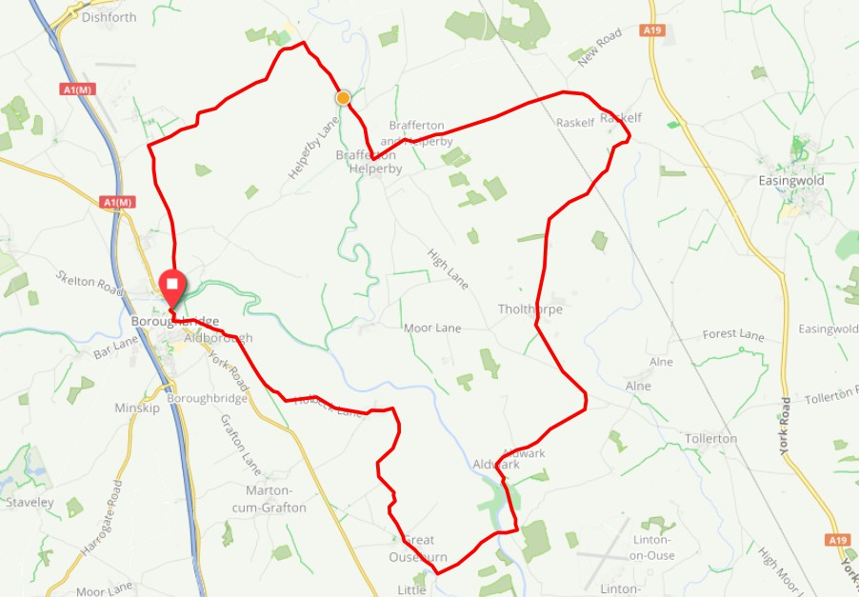

**General risk assessment notes applicable to all rides**

All riders should be encouraged to take part in activities that are within their capabilities.

All riders must wear a helmet.

High vis clothing to be considered for road riding.

The session leader should have checked the leader pack as per insert and have leader pack with them at all times. This must include first aid.

Sun protection and water advisable to be carried.

For exposed routes or winter rides suitable clothing is essential along with spare water or windproof items.

All ride leaders should familiarise themselves with the contents of the ride leader pack specifically tools, spares, first aid and survival equip.

Ride leader should carry suitable navigation aids and check route assessment before commencing ride.