**Tandem Trekkers - Trailer loading notes / advice**

**Sketch layouts**

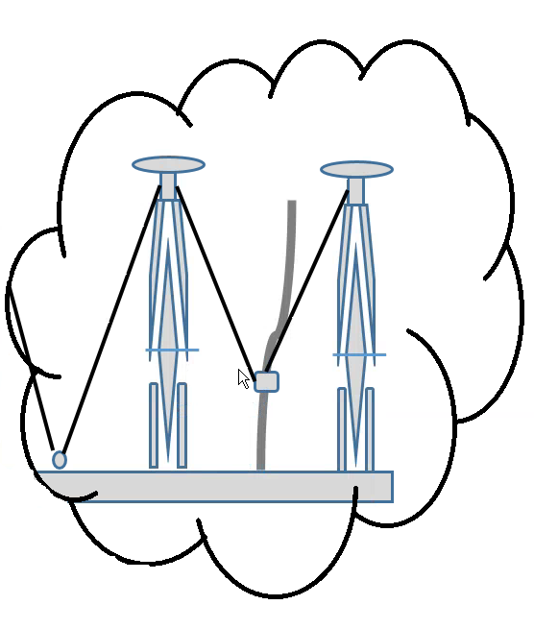

**Notes and advice for those using the trailer – basic procedure** – each trailer driver must check that they consider they have a safe load –it is the driver’s legal responsibility!

1. Upon arrival
   1. Park trailer, consider need for wheel chocks depending on slope / ground – there’s 2 sets of “Biggles” chocks in the rope bag
   2. Unhitch electrics
   3. Lower jockey wheel
   4. Lower rear props
   5. Unlatch and lower tailgate
2. Engage highest gear (smallest sprocket) on rear mech before attempting to load – this minimises chance of damage to rear derailleur
3. Remove pilot seat / stokers bars before loading- if there is a stokers brake lever then turn bars through 90 degrees
4. Load tandem either nose or stern first in either slot 2 or 6
5. Each tandem needs at least 3 straps
   1. One for the nose in wheel to be tied to the front tie bar
   2. Two straps to go from seat post to floor points
   3. Always tie the strap around a fixed point not just around a tube it can slide along, a sliding strap will always deflect the moving bar and then go slack
6. Once loaded strap the tandem’s nose in wheel to the front bar
7. Wrap the buckle end of a strap several (3 / 4/ 5 ) times around the seat post leaving four to six inches free and then thread the tail end through the floor point and back up to the buckle
8. Tighten the first strap approximately to produce an upright bike
9. Wrap another strap around the seat post / fixed point and again go to a floor / fixed point (eg. junction of upright post with side rail) and tighten against the first to produce an upright tightly fixed bike. You should end up with a bike strapped at the nose with 2 wheels fixed in racks and a pair of straps acting in a triangular motion against fixed points holding the bike in place.
10. Load the next tandem into the next most inner slot but in the reverse direction of the first
11. Repeat the strapping
12. Once 2 bikes are in place consider adding the cross strut by attaching each end to a bike, the cross strut brackets may need to be loosened and slid to size but remember to retighten the bracket
13. Repeat until 5 tandems are loaded in the inner bays – i.e. those numbered 2 to 6
14. Only if carrying more than 5 should the outer 2 bays be considered
15. Give consideration to one or more straps across multiple tandems as additional security
16. To load outer bays
    1. Lift tandem into place
    2. Remove pilot seat and stoker bars
    3. **ESSENTIAL TASK Undo and twist through 90 degrees the main pilots handlebar otherwise trailer will be over width**
    4. Strap wheel to front bar
    5. Pad upright strut if necessary
    6. To triangulate straps it may be necessary to take one strap to the junction of the upright strut and the side rail and then take another strap to an inner tandems seatpost point – when strapping look for fixed points not places where straps may slide
    7. Consider adding a cross beam
17. BEFORE SETTING OFF
    1. Raise tailgate
    2. Latch and add security pins
    3. Make sure safety strop is on tow hitch
    4. Raise jockey wheel and ensure parked tight alongside frame
    5. Raise and secure rear props
    6. Check electrics working – the new LED lighting board does not always cause the audio repeater in your car to work so you need a visual check
    7. Make sure you’ve taken sufficient tools and the rope bag

**IF IN DOUBT ASK ADVICE AND ALWAYS CONSIDER AN EXTRA STRAP FOR SECURITY IF CONCERNED ABOUT YOUR LOAD**