**Tandem Trekkers Route Assessment**

**Ride route: Monsall Trail – Hassop Dale to Monsal Top and/or Bakewell viaduct**

**OS Grid ref:- SK 217 071 to SK 114 727 (lower extension SK 217 071 to SK 230 679)**

Approx route/circuit length: 7 miles of well surfaced cycle path from the visitor centre at Hassop dale to the head of the trail at Monsal Top, on return to the start point there is a possibility to go South to the final extent of the trail at Bakewell giving an 18 mile trip for the day.

**Note. It is possible form the southern end to access Bakewell but involves a steep walk from the trail down to the B road which gives access to the town**.

**Terrain**

The route is all reasonably gentle gradients with good surface but some tunnels which may be disconcerting to raw beginners but are generally not problematic..

**Other potential users of circuit or route (such as pedestrains, horses, cars etc):**

This trail is very popular with tourists, families and dog walkers so expect to meet people / animals and other cyclists.

**Note. Recommend only riding this trail in the off season not height of summer to avoid too much traffic.**

**RIDE LEADER TO SCOPE EXTENT OF ACTUAL RIDE TO BE UNDERTAKEN.**

Date / details of route assessment :

14th April 2017 - Barney Harle – route ridden on a solo recumbent on a busy weekend including diversions into Bakewell and the head of the trail. Total time for 22 miles – 3.5 hours including diversions off trail.

**Car parking / trailer parking notes:**

Recommend parking at the visitor centre at Hassop Dale and putting trailer in front of cycle shop (with wheel clamp) the bike shop have previously agreed to this arrangement and the café offers toilets and good refreshments.

**Schedule of route / waymarks / particular hazards (points should appear on annotated map)**

|  |  |  |  |  |  |
| --- | --- | --- | --- | --- | --- |
|  |  |  |  |  |  |
| Nr | Grid ref | Distance from start  (miles) | Risk Description | Mitigation | Risk rating  Low / Med / High |
| 1 | SK 217 071 | Start | On leaving visitor centre turn right onto trail. | Brief riders before leaving or there is a danger riders will set off in wrong direction. | Low |
| 2 | SK 114 727 | 7.0 | Top of trail – there are signs for a tea hut in the valley below – NOT RECOMMENDED – steep broken descent to a very poor tea hut. |  | Turn point |
| 3 | SK 230 679 | 2.0 Extension after returning to Start | Bottom of trail at Bakewell viaduct – proficient pairings may choose to walk the descent and venture into Bakewell – not very promising and over priced tourist shops. | General care and caution if walking down broken descent | Low - MED |

**GENERAL WARNING** - Very popular tourist route

This is can be a very popular route with multiple bike hire shops and car parks therefore not a route for high speed antics or use in high summer when it will be even busier.

**Annotated map**

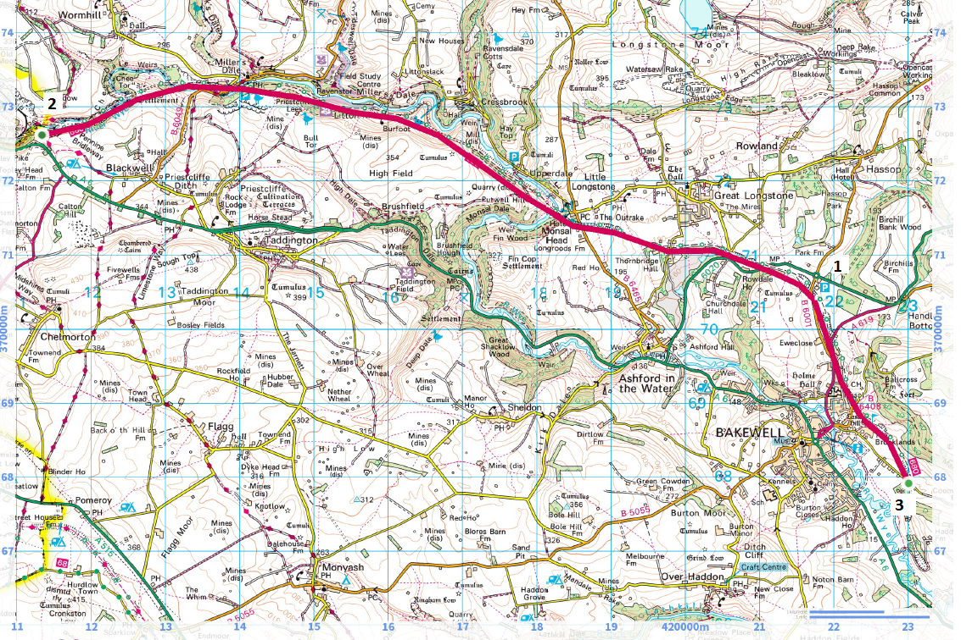**General risk assessment notes applicable to all rides**

* All riders should be encouraged to take part in activities that are within their capabilities.
* All riders must wear a helmet.
* High vis clothing to be considered for road riding
* The session leader should have checked the leader pack as per insert and have leader pack with them at all times. This must include first aid.
* Sun protection and water advisable to be carried.
* For exposed routes or winter rides suitable clothing is essential along with spare water or windproof items
* All ride leaders should familiarise themselves with the contents of the ride leader pack specifically tools, spares, first aid and survival equip.
* Ride leader should carry suitable navigation aids and check route assessment before commencing ride.

**Rider information form**

**Ride**

**Date**

**Ride leader**

|  |  |  |  |  |  |
| --- | --- | --- | --- | --- | --- |
| Name | Pilot / stoker | Level of visual impairment | Contact number on day | Emergency contact | How travelling to ride |
|  |  |  |  |  |  |
|  |  |  |  |  |  |
|  |  |  |  |  |  |
|  |  |  |  |  |  |
|  |  |  |  |  |  |
|  |  |  |  |  |  |
|  |  |  |  |  |  |
|  |  |  |  |  |  |
|  |  |  |  |  |  |
|  |  |  |  |  |  |
|  |  |  |  |  |  |
|  |  |  |  |  |  |