**Tandem Trekkers Route Assessment**

**Ride route: High Peak Trail –Parsley Hay to Middleton Top**

**OS Grid ref:- SK 146 636 to SK 277 522**

Approx route/circuit length: 11 miles of reasonably well surfaced gravel cycle path between two visitor centres.

**Note** the route extends South East of Middleton Top but involves very steep gradients – NOT RECOMMENDED unless desperate for hill climbing practice.

**Terrain**

The route is all reasonably gentle gradients but is generally very exposed and crosses open moorland so is weather susceptible.

The surface of the route is very fine ravel and dust so can give off quite a mucky spray when wet – consider bike washing after such a trip

**Other potential users of circuit or route (such as pedestrains, horses, cars etc):**

This trail is reasonably popular with horse riders, families and dog walkers so expect to meet people / animals and other cyclists.

**RIDE LEADER TO SCOPE EXTENT OF ACTUAL RIDE TO BE UNDERTAKEN.**

Date / details of route assessment :

11th April 2016 - Barney Harle – route ridden on a solo hybrid with road tyres –entire section of ride taken comfortably at speed. Ridden as part of a larger loop but this section covered (one way) in 1 hour.

**Car parking / trailer parking notes:**

There are options to ride this route form either end, at each end of the ride there are visitor centres with cafes and parking, Parsley Hay has the larger car park but is at the uphill end of the trail. (This is the car park often used as the set off point for the Tissington Trail)

**Schedule of route / waymarks / particular hazards (points should appear on annotated map)**

|  |  |  |  |  |  |
| --- | --- | --- | --- | --- | --- |
|  |  |  |  |  |  |
| Nr | Grid ref | Distance from start  (miles) | Risk Description | Mitigation | Risk rating  Low / Med / High |
| START | SK 146 636 | 0 | Start point Parsley Hay Visitor Centre |  |  |
| 1 | SK 148 633 | 0.25 | Almost immediately after leaving the visitor centre the trail splits, LEFT for Middleton Top – THE REQUIRED OPTION , right takes you onto Tissington Trail. | Brief riders before leaving or there is a danger riders will set off in wrong direction. | Low |
| 2 | SK 181 597 | 3.1 | MAJOR ROAD crossing of A road – this is an uncontrolled junction but with very good visibility – it should not be a problem but care needs to be exercised. Immediately before and after the crossing there are gates to control cycle traffic. | General care and caution | Med |
| 3 | SK 193 582 | 4.6 | B road ,trail junction and car park. This junction is obvious and you are required to leave the trail via a gate before making the crossing – it is far less serious than road crossings on the Calder Greenway.  Take care in car park areas for vehicles, families and pets | General care and caution | Low |
| 4 | SK 261 546 | 10.0 | 3 way A road, B road ,trail junction. This junction is obvious and you are required to leave the trail via a gate before making the crossing – it is no more serious than road crossings on the Calder Greenway. | General care and caution – but also consider posting sentries if a large number of riders or poor visibility. | Low - Med |
| END | SK 277 522 | 11.0 | End point Middleton Top Visitor Centre |  |  |

**GENERAL WARNING** - Exposed moorland route

This is an exposed moorland route and the danger of people suffering hypothermia if the weather is poor or changes suddenly must not be underestimated. All riders need to be aware of the risk and suitable clothing needs to be considered.

In the event of group members exhibiting early signs of hypothermia early preventative action is essential.

DO NOT PUSH ON REGARDLESS – CONSIDER OPTIONS CAREFULLY!

**Annotated map**

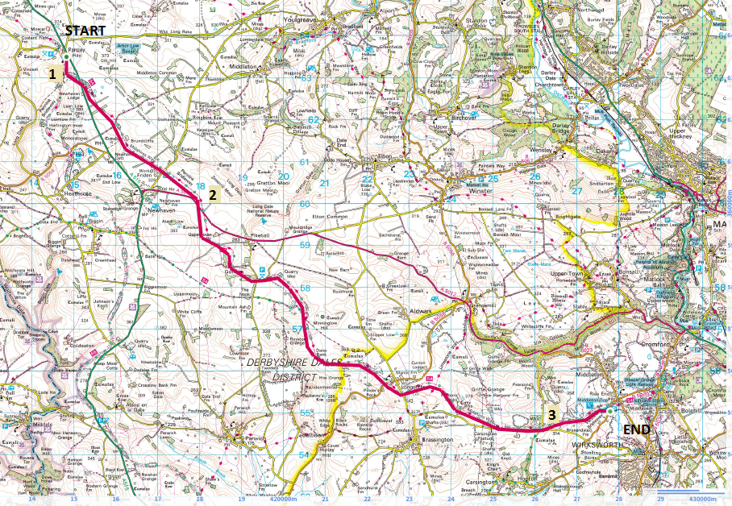**General risk assessment notes applicable to all rides**

* All riders should be encouraged to take part in activities that are within their capabilities.
* All riders must wear a helmet.
* High vis clothing to be considered for road riding
* The session leader should have checked the leader pack as per insert and have leader pack with them at all times. This must include first aid.
* Sun protection and water advisable to be carried.
* For exposed routes or winter rides suitable clothing is essential along with spare water or windproof items
* All ride leaders should familiarise themselves with the contents of the ride leader pack specifically tools, spares, first aid and survival equip.
* Ride leader should carry suitable navigation aids and check route assessment before commencing ride.

**Rider information form**

**Ride**

**Date**

**Ride leader**

|  |  |  |  |  |  |
| --- | --- | --- | --- | --- | --- |
| Name | Pilot / stoker | Level of visual impairment | Contact number on day | Emergency contact | How travelling to ride |
|  |  |  |  |  |  |
|  |  |  |  |  |  |
|  |  |  |  |  |  |
|  |  |  |  |  |  |
|  |  |  |  |  |  |
|  |  |  |  |  |  |
|  |  |  |  |  |  |
|  |  |  |  |  |  |
|  |  |  |  |  |  |
|  |  |  |  |  |  |
|  |  |  |  |  |  |
|  |  |  |  |  |  |