**Tandem Trekkers Route Assessment**

**Ride route: York Selby Railway Path – York Racecourse - Riccall**

**OS Grid ref:- SE 595 500 to SE 622 383**

Approx route/circuit length: 17 (return trip) miles of reasonably well surfaced tarmac / gravel cycle path.

**Note** the route extends South of Riccall as far as Selby but this requires a little more navigation and road riding experience.

**Terrain**

The route is all essentially flat with virtually no gradients or elevation – it is however a converted railway line in open country so can be susceptible to wind.

The surface of the route is a mixture of tarmac and gravel with occasional sections of tree roots.

**Other potential users of circuit or route (such as pedestrains, horses, cars etc):**

This trail is very popular with horse riders, families and dog walkers so expect to meet people / animals and other cyclists.

**RIDE LEADER TO SCOPE EXTENT OF ACTUAL RIDE TO BE UNDERTAKEN.**

Date / details of route assessment :

4th January 2018 - Barney Harle – route ridden on a solo hybrid with road tyres –entire section of ride taken comfortably at speed. Approx time for majority of return trip 90 minutes.

**Car parking / trailer parking notes:**

There are options to ride this route from either end, however this assessment assumes commencing from York Racecourse where parking is usually available in a number of locations.

**Schedule of route / waymarks / particular hazards (points should appear on annotated map)**

|  |  |  |  |  |  |
| --- | --- | --- | --- | --- | --- |
|  |  |  |  |  |  |
| Nr | Grid ref | Distance from start  (miles) | Risk Description | Mitigation | Risk rating  Low / Med / High |
| START | SE 595 500 | 0 | Knavesmire, York  Initially it will be necessary to navigate around / through the racecourse to access the trail – this is well signposted but not recommended on race days. | Brief riders before leaving or there is a danger riders will set off in wrong direction. | Low |
| 1 | SE 588 482 | 1.6 | After leaving the racecourse the trail squeezes alongside the A64 (but segregated by a fence) for a section which is relatively easily ridden but needs to be taken in single file and other traffic may be encountered. Due to proximity to the A64 traffic noise can prevent easy verbal communication between tandems. | Brief riders before leaving so they are not surprised | Low |
| 2 | SE 584 480 | 2 | Start of the planetary / solar system trail. | Navigation note |  |
| 3 | SE 588 475 | 3 | For a short section the trail runs through a residential street that has been built across the old railway line. This is a quiet residential area but riders need to be aware of cars, pedestrians, children. | General care and caution | Low |
| 4 | SE 591 472 | 4 | Café / garden centre / farm shop – useful point for stop off on outward and or return portion of route. This is also an exit point from the route if wanting to visit the pub / marina in Naburn. | Navigation note |  |
| END | SE 622 383 | 8.5 | Turn point at Riccall |  |  |

**GENERAL WARNING** -

This route can be very popular so beware of other users and their lack of appreciation of the size of tandems.

**Annotated map**

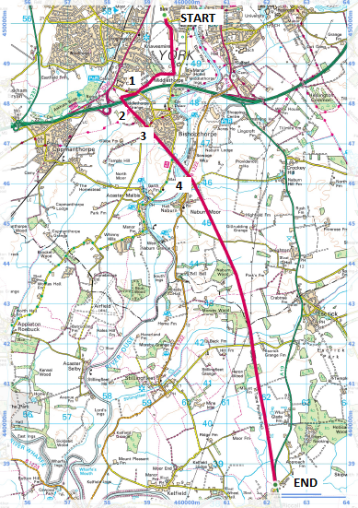

**General risk assessment notes applicable to all rides**

* All riders should be encouraged to take part in activities that are within their capabilities.
* All riders must wear a helmet.
* High vis clothing to be considered for road riding
* The session leader should have checked the leader pack as per insert and have leader pack with them at all times. This must include first aid.
* Sun protection and water advisable to be carried.
* For exposed routes or winter rides suitable clothing is essential along with spare water or windproof items
* All ride leaders should familiarise themselves with the contents of the ride leader pack specifically tools, spares, first aid and survival equip.
* Ride leader should carry suitable navigation aids and check route assessment before commencing ride.

**Rider information form**

**Ride**

**Date**

**Ride leader**

|  |  |  |  |  |  |
| --- | --- | --- | --- | --- | --- |
| Name | Pilot / stoker | Level of visual impairment | Contact number on day | Emergency contact | How travelling to ride |
|  |  |  |  |  |  |
|  |  |  |  |  |  |
|  |  |  |  |  |  |
|  |  |  |  |  |  |
|  |  |  |  |  |  |
|  |  |  |  |  |  |
|  |  |  |  |  |  |
|  |  |  |  |  |  |
|  |  |  |  |  |  |
|  |  |  |  |  |  |
|  |  |  |  |  |  |
|  |  |  |  |  |  |