**Tandem Trekkers Route Assessment**

**Ride route: Glasson Dock loop back via Lancaster, Halton, Hest Bank and Morecambe**

**OS Grid ref:- SD 445 556 loop back to start**

Approx route/circuit length: 24 miles of reasonably well surfaced gravel cycle path, minor an small amount of major roads.

**Terrain**

The route is all reasonably flat except for the 3 mile road section in the middle of the ride where the route makes a small climb followed by a descent back to the seafront. The roads are used are all relatively quiet but once there are a couple of A road stretches and crossings – nothing more major than experienced on other similar rides.

**Other potential users of circuit or route (such as pedestrains, horses, cars etc):**

This trail is reasonably popular with horse riders, families and dog walkers so expect to meet people / animals and other cyclists.

The road section is all relatively quiet but does involve a staggered A road cross roads at Hest Bank.

**RIDE LEADER TO SCOPE EXTENT OF ACTUAL RIDE TO BE UNDERTAKEN.**

Date / details of route assessment :

17th August 2019 - Barney Harle & Chris Vaughan – route ridden on a touring tandem with 35mm road tyres. All route taken including café stop and off route investigations in a total time of 3 hours 15 minutes..

**Car parking / trailer parking notes:**

Large gravel pay and display car park at start of ride with public (pay to use) toilets opposite.

BEWARE – TRAILER DRIVERS DO NOT FOLLOW SAT NAV USE YOUR BRAINS AND GOOGLE EARTH – THE LANES ARE NARROW CONSIDER USING M6 JUNC 34.

Various café options at start end and mid points. Suggest a café stop at Stone Jetty Cafe – approx. 15 miles and then ice cream at the end while trailer loading takes place.

**Schedule of route / waymarks / particular hazards (points should appear on annotated map)**

|  |  |  |  |  |  |
| --- | --- | --- | --- | --- | --- |
|  |  |  |  |  |  |
| Nr | Grid ref | Distance from start  (miles) | Risk Description | Mitigation | Risk rating  Low / Med / High |
| START | SD 445 556 | 0 | Start point Glasson Dock car park – LA2 0BT |  |  |
| 1 | SD 459 617 | 4.4 | Leave trail to use quiet industrial estate road | Warning and regroup at gate | Low |
| 2 | SD 468 622 | 5.1 | Leave road on left hand side to use shared use foot path / cycleway parallel with road. | General care and caution on dropped kerb transfer | Low |
| 3 | SD 475 620 | 5.6 | Follow trail onto Millenium bridge – BEWARE metal surface if wet, then turn right to continue to follow river upstream. | General care and caution | Low |
| 4 | SD 478 620 | 5.8 | Depending upon roadworks on the main bridge it may be necessary to use the switchback underpass beside Sainsbury’s car park. | General care and caution | Low |
| 5 | SD 495 644 | 7.8 | Navigation point - crossing under M6 | NIL | NIL |
| 6 | SD 503 645 | 8.3 | Leave trail and cross river on road bridge at Halton  Immediately after leaving bridge STOP sign before left hand turn onto B road | General care and caution Possibly brief riders to change down ahead of roundabout | Med |
| 7 | SD 500 648 | 8.6 | Mini roundabout – take second exit i.e. straight over – from this point on the road climbs for approximately 1 mile | General care and caution | Med |
| 8 | SD 490 653 | 9.4 | B Road cross roads – NOTE STOP sign | General care and caution | Med |
| 9 | SD 487 654 | 9.6 | Navigation point – Summit of climb | General care and caution as enter descent | Low |
| 10 | SD 483 655 | 9.8 | B Road cross roads taken on descent so caution! | General care and caution as descending | Low |
| 11 | SD 477 659 | 10.3 | Staggered cross roads – left onto A road then immediate right onto B road | General care and pilots may benefit from outrider as warning | Med - High |
| 12 | SD 471 666 | 11.1 | Turn left onto coast road – quieter A road | General care and caution | Low |
| 13 | SD 461 659 | 11.9 | Turn right across traffic at T junction to enter coastal path parallel to A road | General care and caution | Med |
| 14 | SD 425 647 | 14.6 | Navigation point – Stone Jetty Café – suggested mid ride stop | Beware pedestrian traffic | Low |
| 15 | SD 427 642 | 14.8 | Leave coastal route to enter road at roundabout for approx. 200 metres before turning right into Morrisons supermarket car park and then onto rail trail | Beware vehicular traffic | Med |
| 16 | SD 425 647 | 15.5 | Gated railway crossing – dismount and manage gates between group | Beware railway traffic and other users | Low |
| 17 | SD 475 620 | 18.3 | Cross Millenium bridge – beware metal grid surface to refollow trail downstream back to Glasson Dock | Beware pedestrian traffic | Low |
| 18 | SD 468 622 | 18.8 | Leave shared path / trail on left hand side to use road. | General care and caution on dropped kerb transfer | Low |
| 19 | SD 459 617 | 19.4 | Re-enter Glasson Dock trail from industrial estate | Warning and regroup at gate | Low |
| END | SD 445 556 | 24 | End point Glasson Dock car park |  |  |
|  |  |  |  |  |  |

**GENERAL WARNING** - Portions of the route include roads, climbs, road junctions and exposed coastal path – all are within most riders capabilities but do require a degree of confidence and the route is not recommended for novice riders.

**General risk assessment notes applicable to all rides**

* All riders should be encouraged to take part in activities that are within their capabilities.
* All riders must wear a helmet.
* High vis clothing to be considered for road riding
* The session leader should have checked the leader pack as per insert and have leader pack with them at all times. This must include first aid.
* Sun protection and water advisable to be carried.
* For exposed routes or winter rides suitable clothing is essential along with spare water or windproof items
* All ride leaders should familiarise themselves with the contents of the ride leader pack specifically tools, spares, first aid and survival equip.
* Ride leader should carry suitable navigation aids and check route assessment before commencing ride.

**Rider information form**

**Ride**

**Date**

**Ride leader**

|  |  |  |  |  |  |
| --- | --- | --- | --- | --- | --- |
| Name | Pilot / stoker | Level of visual impairment | Contact number on day | Emergency contact | How travelling to ride |
|  |  |  |  |  |  |
|  |  |  |  |  |  |
|  |  |  |  |  |  |
|  |  |  |  |  |  |
|  |  |  |  |  |  |
|  |  |  |  |  |  |
|  |  |  |  |  |  |
|  |  |  |  |  |  |
|  |  |  |  |  |  |
|  |  |  |  |  |  |
|  |  |  |  |  |  |
|  |  |  |  |  |  |

**Annotated map**

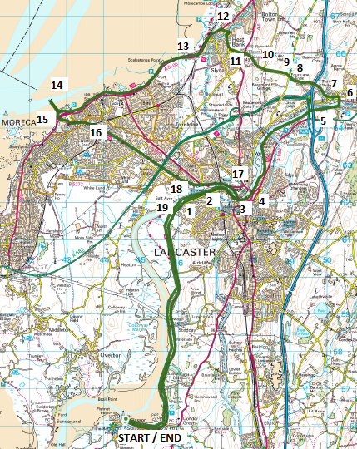 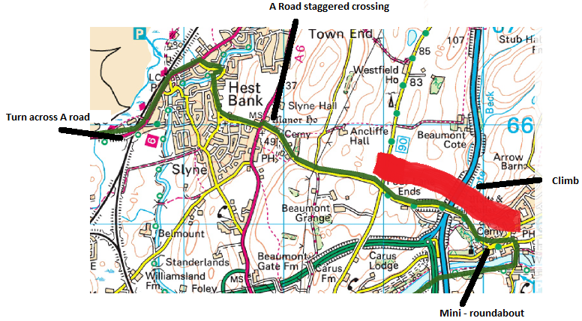

Blown up section 6 - 13