**Tandem Trekkers Route Assessment**

**Ride route: Around Clitheroe**

Route Assessed: Paul Stark and Martin Eatherley rode a tandem on 12 July 2017. Weather: Warm and Sunny. The route has subsequently been ridden on two separate occasions by Trekkers

The route is entirely on road and is mainly on quiet country roads but includes short sections on busier A - Roads

The total distance is 33.5 km and includes 362 m of ascent / descent. There is one particularly steep ascent – Grindleton Brow

Being in a rural setting it is reasonable to encounter larger than normal agricultural vehicles which can be slow moving. Some lanes are also used by horse riders which should be passed slowly and widely when safe to do so and after giving a verbal alert to the rider.

|  |  |  |  |  |
| --- | --- | --- | --- | --- |
|  |  |  |  |  |
| Nr | Approx distance from start  (miles) | Risk Description | Mitigation | Risk rating  Low / Med / High |
| START | 0.0 | Start point – Spring Wood Picnic Site, Whalley |  |  |
| 1 | 0.1 – 1.0 km | Route crosses busy A671 and immediately descends on B6246 into Whalley Village | Cross on Green Traffic Light and moderate speed on descent using drag brake | Low |
| 2 | 15.5 km | Gradient of up to 15 % for approx. 200m at Grindleton Brow | Tandem pairs should be prepared to dismount and walk bikes to crest | Low |
| 3 | 19.2 km | Route meets very busy A59 Dual Carriageway with fast moving traffic. | Do not join A59 but ride on cycle path/footpath | Low/Medium |
| 4 | 19.2- 20.0 km | Cycle Path prone to mud and low over-hanging tree branches | Pilots to tell Stokers when to “duck” and take extra care on any parts of cycle-path that appear muddy. Dismount and walk if required. Tandems to maintain reasonable separation. | Low |
| 5 | 24.8 km | Right turn into Duck Street/ Wellgate immediately after Tesco. Busy town centre ahead with vehicles and pedestrians. | Pull over and walk bikes across road if required. If right turn has been cycled, pull over and dismount on Duck Street. Do not cycle to Brioche café. Walk with appropriate pavement etiquette. | Low |
| 6 | 25.2 km | Leave Brioche Café and cycle slowly. Route crosses Waterloo Road | Extra care and vigilance. Expect lots of traffic and pedestrians who may step off pavement without warning. Bikes are quiet! | Low |
| 7 | 28.0 km | Offset crossroads at very busy A59 Dual Carriageway with fast moving traffic. | Do not cycle across A59 unless you are completely satisfied it is safe to do so and you can initiate a safe start | Medium |
| 8 | 32 – 33.5 km | Busy A671 Trunk Road | Extra care and vigilance. Keep well into left. Back riders to wear hi-viz | Low |
| 9 | END | End point – Spring Wood Picnic Site |  |  |

ELEVATION PROFILE

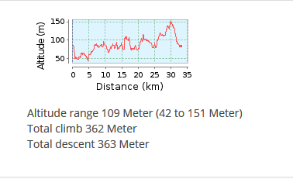

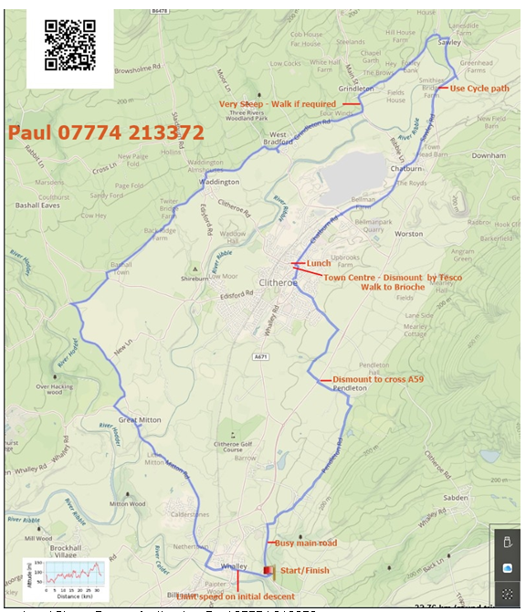

**General risk assessment notes applicable to all rides**

All riders should be encouraged to take part in activities that are within their capabilities.

All riders must wear a helmet.

High vis clothing to be considered for road riding.

The session leader should have checked the leader pack as per insert and have leader pack with them at all times. This must include first aid.

Sun protection and water advisable to be carried.

For exposed routes or winter rides suitable clothing is essential along with spare water or windproof items.

All ride leaders should familiarise themselves with the contents of the ride leader pack specifically tools, spares, first aid and survival equip.

Ride leader should carry suitable navigation aids and check route assessment before commencing ride.