**Tandem Trekkers Route Assessment**

**Ride route: Tissington Trail (Ashbourne – Parsley Hay)**

The Tissington Trail runs for 13.2 miles from Ashbourne (53.0196°N 1.7397°W) in the south to Parsley Hay (53.1706°N 1.7828°W) in the north

The track surface is reasonably compacted crushed limestone. Some pockets can become “clumpy” after heavy rain and extra care needs to be taken. Loose gravel can also build and extra care needs to be taken, especially when braking.

The start elevation at Ashbourne is 230 metres above sea level and rises to 335 metres at Parsley Hay (Maximum Elevation 352 metres). Apart from the removed viaduct at Mapleton (see below) the gradient is gentle. However, at over 1000’ the northern end approaching Parsley Hay is exposed and susceptible to inclement weather and the associated danger of people suffering hypothermia if the weather is poor and/or delays occasioned by mechanical incidents occur. All riders need to be aware of the risk and suitable clothing needs to be worn.

The route has been successfully ridden by Tandem Trekkers on several occasions (annually 2014-19) without incident. It is completely traffic-free. However, the trail is very popular with horse riders, families with young children and dog walkers so expect to meet people / animals and other cyclists riding a variety of equipment. Indeed, at points the track can become slightly congested and narrow. Loud and clear verbal instructions/bell ringing when approaching and passing other trail users need to be used. Dogs and young children can be unpredictable!

|  |  |  |  |  |
| --- | --- | --- | --- | --- |
|  |  |  |  |  |
| Nr | Approx distance from start  (miles) | Risk Description | Mitigation | Risk rating  Low / Med / High |
| START | 0.0 | Start point Ashbourne Car Park DE6 1FD |  |  |
| 1 | 0.05 | Mapleton Lane Cycle Hire Centre can be busy. Visitors hiring bikes from centre start ride here and might be inexperienced. Pilots need to be vigilant and call out, particularly when passing “wobbly” or “novice” cyclists | General care and caution | Low |
| 2 | 0.5 | Trail dips steeply down and up where a viaduct has been removed; Gates give way to both slopes which are about 130 feet (40 m) long with steep gradients of 1:9 . There are half- barriers at the mid-points on both sides of the dip. | Riders should be encouraged to dismount and walk tandems. | Med |
| 3 | 11 | Trail becomes more exposed, particularly after leaving Hartington. Be prepared to turn round at this point if weather is questionable. Wind can gust. | Ride Leader should be satisfied weather is suitable to continue to exposed part of route | Low |
| 4 | 13.0 | Trail is joined from right by High Peak Trail. On return journey it is easy to wrongly keep left. Consider marking junction to prevent riders taking wrong return route | General care and caution – but also consider marking junction if a large number of riders or poor visibility. | Low - Med |
| END |  | End point Parsley Hay Visitor Centre |  |  |

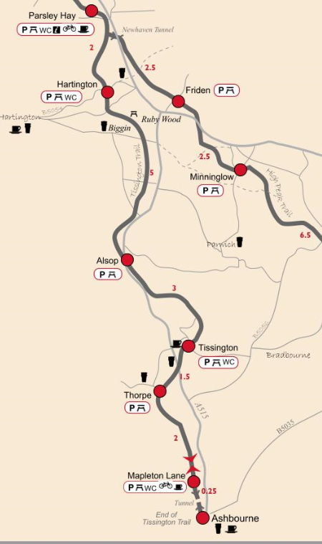**General risk assessment notes applicable to all rides**

All riders should be encouraged to take part in activities that are within their capabilities.

All riders must wear a helmet.

High vis clothing to be considered for road riding.

The session leader should have checked the leader pack as per insert and have leader pack with them at all times. This must include first aid.

Sun protection and water advisable to be carried.

For exposed routes or winter rides suitable clothing is essential along with spare water or windproof items.

All ride leaders should familiarise themselves with the contents of the ride leader pack specifically tools, spares, first aid and survival equip.

Ride leader should carry suitable navigation aids and check route assessment before commencing ride.