**Tandem Trekkers Route Assessment**

**Ride route: Fairburn Loop**

Route Assessed: The route has been ridden on several occasions by Trekkers since 2015. This assessment replaces an earlier assessment due to a different start point

The route is entirely on road and is mainly on quiet country roads but includes a short 300m section on the A19 Trunk Road and a particularly hazardous crossing of the same road

The total distance is 34.38 km and includes 117m of ascent / descent. It is hence essentially a flat route

Being in a rural setting it is reasonable to encounter larger than normal agricultural vehicles which can be slow moving. Some lanes are also used by horse riders which should be passed slowly and widely when safe to do so and after giving a verbal alert to the rider.

|  |  |  |  |  |
| --- | --- | --- | --- | --- |
|  |  |  |  |  |
| Nr | Approx distance from start  (km) | Risk Description | Mitigation | Risk rating  Low / Med / High |
| START | 0.0 | Start point – Birkin Fisheries, Haddlesey Rd, Birkin, Knottingley WF11 9LT |  |  |
| 1 | 1.9 | Bridge over River Aire – Slight incline and narrowing of lane – no side verge. Possible oncoming traffic on bridge which cannot be seen on approach | Extra care and vigilance | Low |
| 2 | 6.2 | Left Give Way to join A19 Busy Trunk Road for 300m. Fast moving traffic. | Extreme care and vigilance. Bikes to approach junction slowly and be prepared to stop. Ride Leader or nominee to oversee joining of A19 and give clear verbal guidance if safe to join without stopping but final decision to stop or continue rests with pilot. | Med |
| 3 | 6.5 | Right Turn off A19 into Wand Lane. Fast moving traffic in both directions | Extreme care in executing a right turn into Wand Lane by joining dedicated right turn lane after giving a clear hand signal. If no suitable traffic gap bikes to pull over on left and mount grass side verge off road before walking bikes across A19 | Med-High |
| 4 | 24.5 | Route re-crosses A19. Fast moving traffic and restricted view to south. Mandatory STOP sign | Extreme care. All bikes to approach junction slowly and STOP. Mark junction and proceed when safe. Ride Leader or nominee to supervise crossing. | High |
| 5 | 24.6 | Congestion risk at re-group point after crossing A19. Stop away from junction and parked cars on Millfield Lane | Ensure bikes are stopped away from junction and adequate clearance for other road users maintained | Low |
| 6 | 34.0 | Junction into Haddlesey Road is easily overshot on return | Mark Junction. | Low |
| 7 | END | End point – Birkin Fisheries, Haddlesey Rd, Birkin, Knottingley WF11 9LT |  |  |

ELEVATION PROFILE

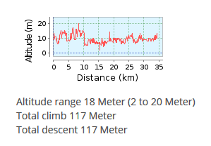

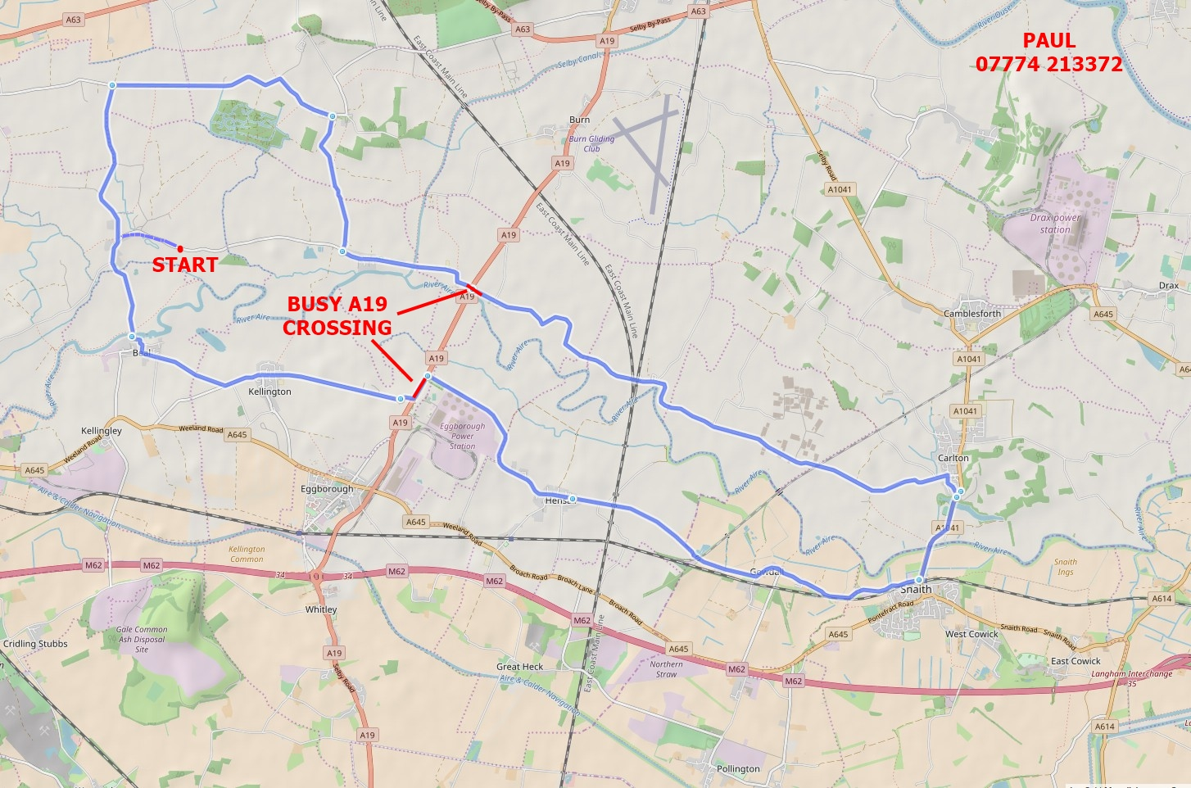

**General risk assessment notes applicable to all rides**

All riders should be encouraged to take part in activities that are within their capabilities.

All riders must wear a helmet.

High vis clothing to be considered for road riding.

The session leader should have checked the leader pack as per insert and have leader pack with them at all times. This must include first aid.

Sun protection and water advisable to be carried.

For exposed routes or winter rides suitable clothing is essential along with spare water or windproof items.

All ride leaders should familiarise themselves with the contents of the ride leader pack specifically tools, spares, first aid and survival equip.

Ride leader should carry suitable navigation aids and check route assessment before commencing ride.